Tax Year 2020 Wage File Upload Tutorial

Follow the instructions below to submit a W-2 Wage File, a W-2c Wage File, a Resubmission File, a Reconciliation File, or a Special Wage Payments File to the Social Security Administration (SSA).
For information on preparing formatted W-2 files for electronic filing (EFW2, formerly MMREF-1), or W-2c files (EFW2C, formerly MMREF-2), go to the Publications & Forms page on employer web site.
Submit a reconciliation file to the SSA only when you have received a letter from the SSA notifying you of a discrepancy between money amounts shown on a Form W-3 sent to the SSA and a Form 941 sent to the IRS.

Step-By-Step Instructions for Submitting a Wage File
- Select Business & Government tab on the “Social Security” home page, then select Business Services menu to go to the “Business Services” page. On the “Business Services” page, select Log in or Use Business Services Online button to go to the “Business Services Online” page.
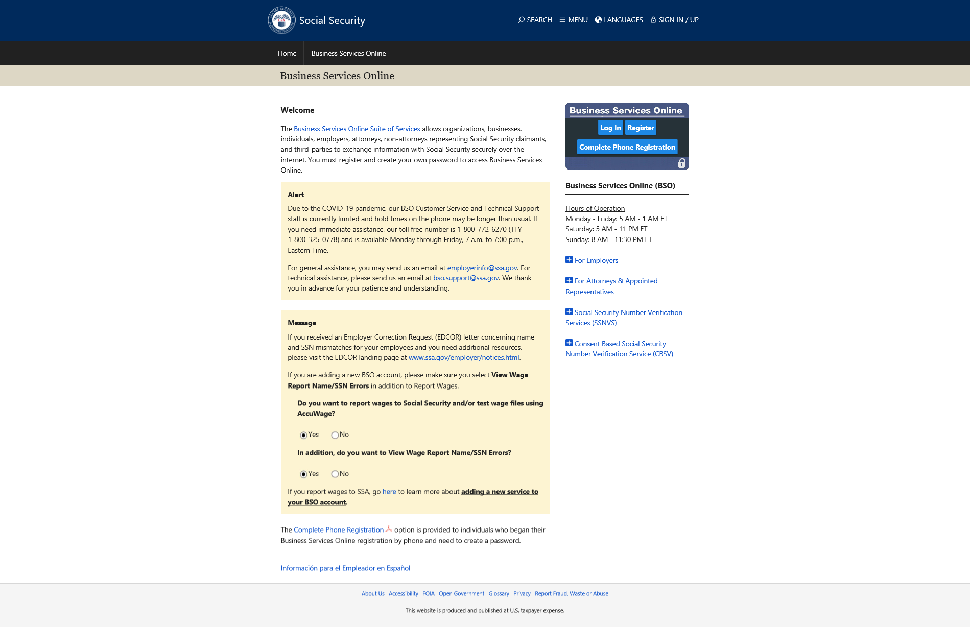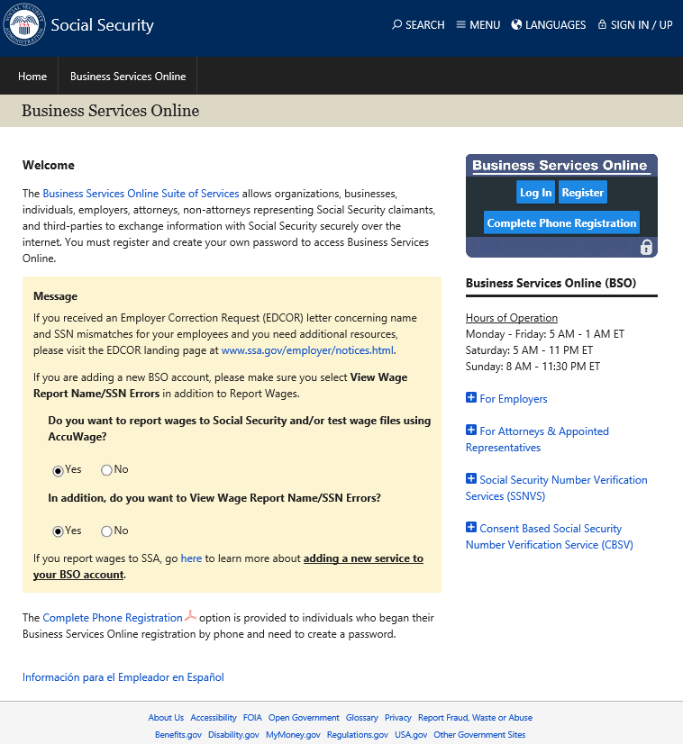
- Select the Log In button on the “Business Services Online” page. The system displays the “Log In to Online Services” page.
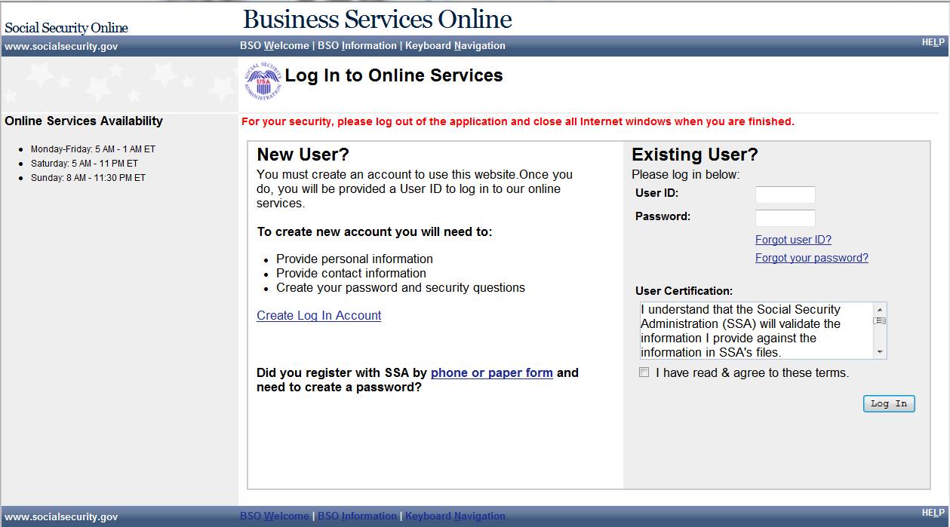
- Enter your User ID and Password.
- Select the I have read & agree to these terms check box on the “Log In to Online Services” page.
  - Select the Log In button to display the BSO “Main Menu” page.
  - To return to the “Business Services Online” page, select the BSO Welcome link at the top or bottom of the page.

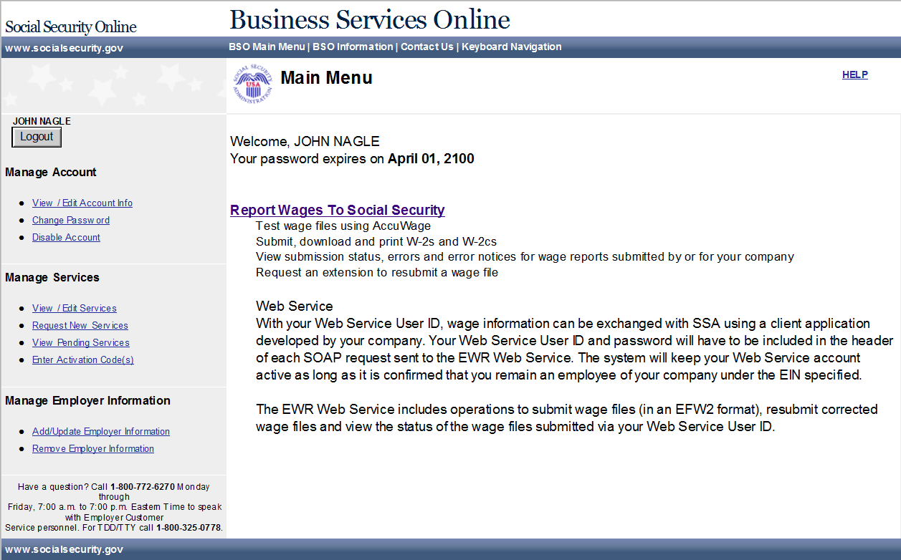
- Select the Report Wages To Social Security link on the BSO “Main Menu” page. The system displays the “Wage Reporting Attestation” page.
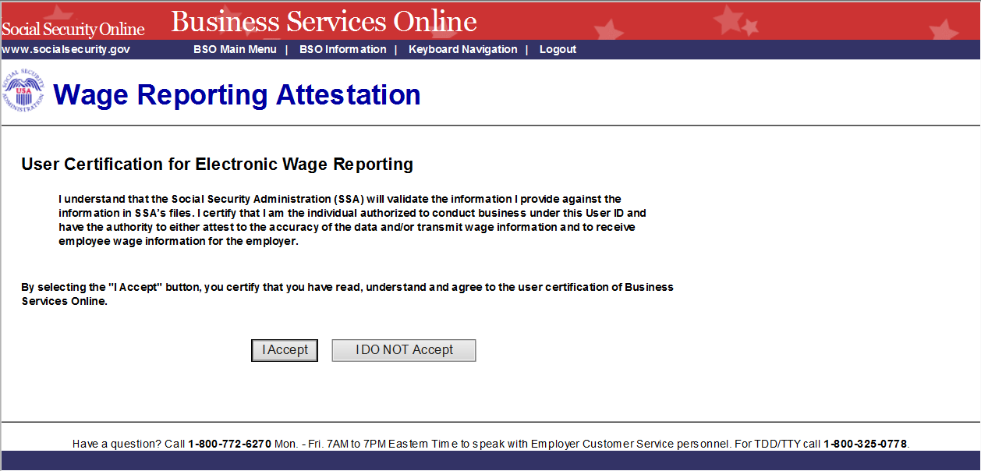
- Select the I Accept button on the “Wage Reporting Attestation” page to go to the “EWR home” page. To return to the BSO “Main Menu” page, select the I DO NOT Accept button.
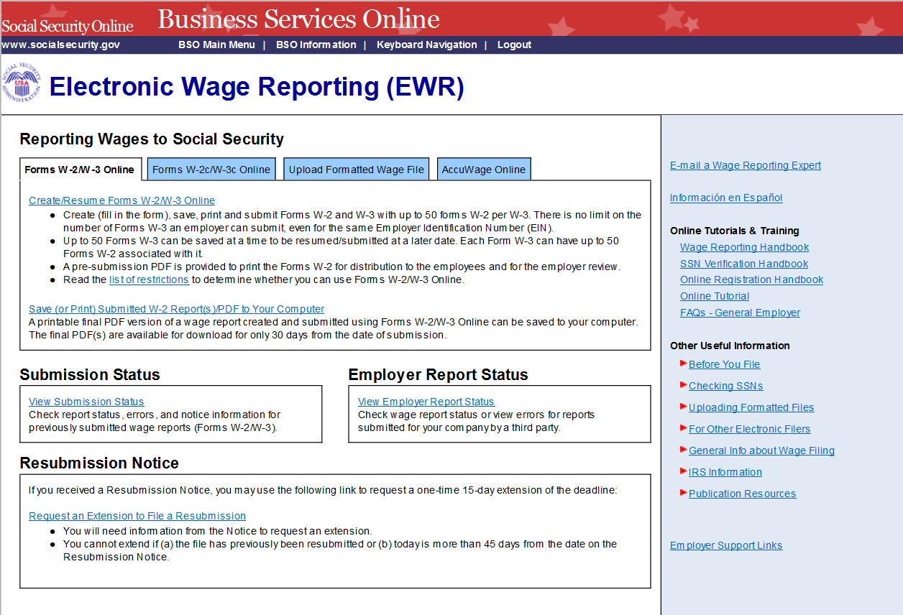
- Select the Upload Formatted Wage File tab to access Wage File Upload application.
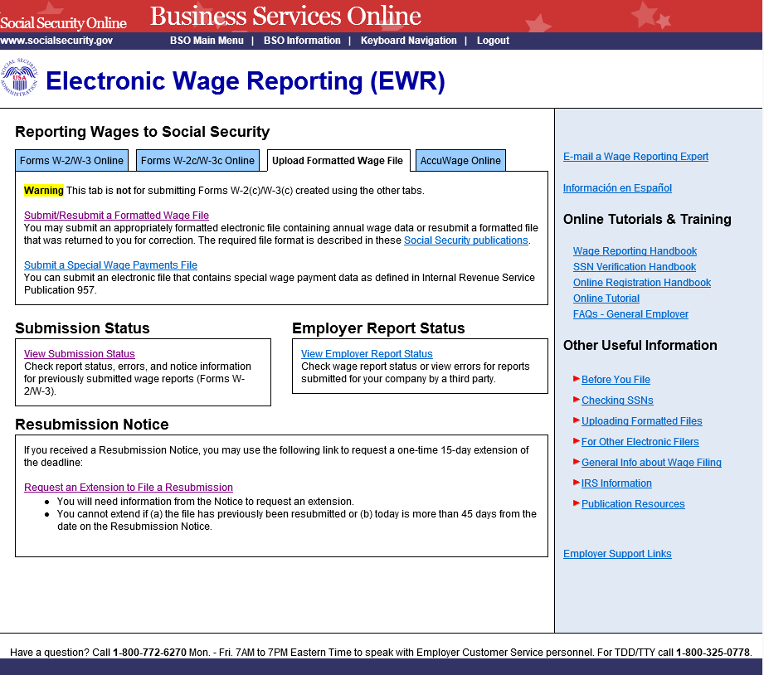

- Under the tab Upload Formatted Wage File on the EWR home page, select the Submit/Resubmit a Formatted Wage File link, the system displays the “Before You Start” page.
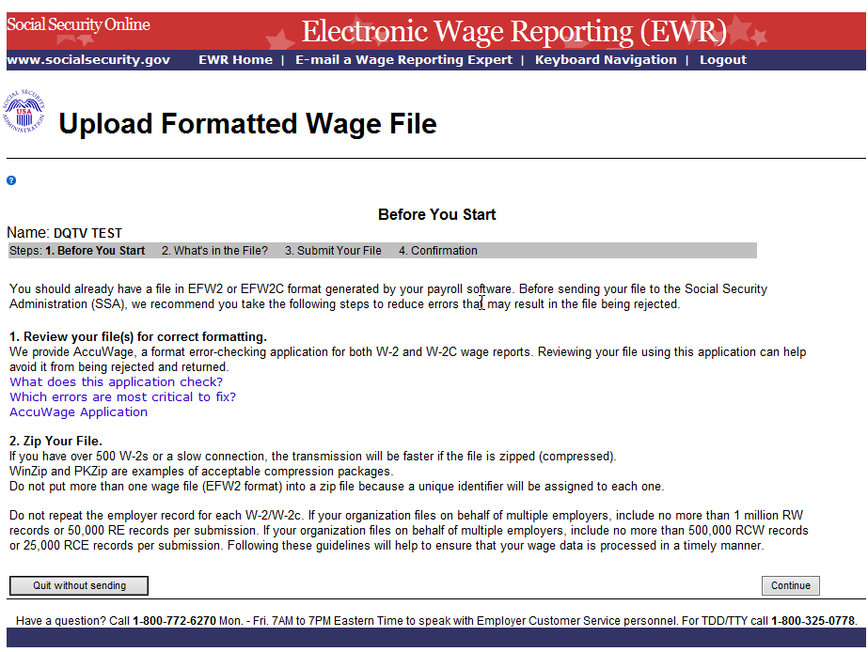
- Select the Continue button, the system displays the “What’s in the File?” page.
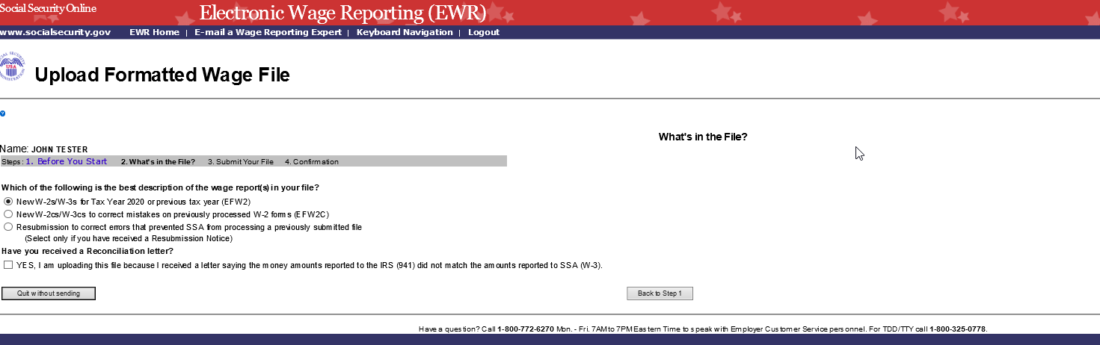
- Choose the type of wage file you want to submit:
  - Select the New W-2s/W-3s for Tax Year 2020 or previous tax year (EFW2) radio button to submit a W-2 wage file.
  - Select the New W-2cs/W-3cs to correct mistakes on previously processed W-2 forms (EFW2C) radio button to submit a W-2c wage file.
  - Select the Resubmission to correct errors that prevented SSA from processing a previously submitted file radio button to submit a Resubmission file. The system will display two extra fields: Original receipt year and WFID (see the screenshot below). You can get this information from the Resubmission Notice. This option should be used only if you have received a notice from the SSA asking you to correct and resubmit your data. The Employer Identification Number (EIN) of the person resubmitting wage data to SSA must match the EIN of the person who originally submitted the file.
  - If you received a Reconciliation letter, select the check box.
  - To return to the EWR home page, select the Quit without sending button.
  - To return to the “Before You Start” page, select the Back to Step 1 button.
  - To submit a file, select Continue button to go to the “Submit Your File” page.
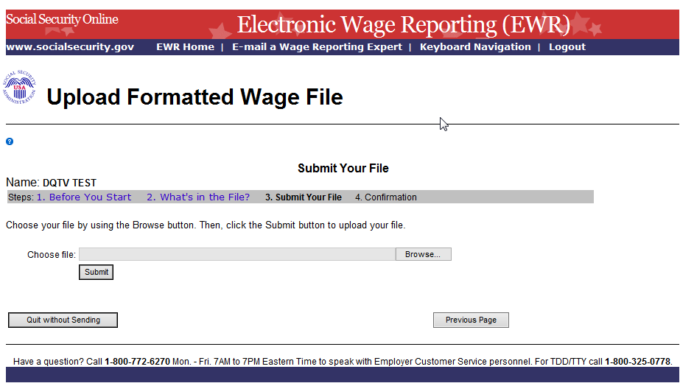
- On the Submit Your File page:
  - Enter the name of a wage file in the Choose file field, or use the Browse button to select a wage file from your computer’s file system.
  - Select the Submit button to upload your file. During file transmission, an “in progress” window is displayed. When the file upload is completed, the system displays the “Confirmation – Your File Was Received” page. A pop-up window advising you to save and/or print the page will also appear.
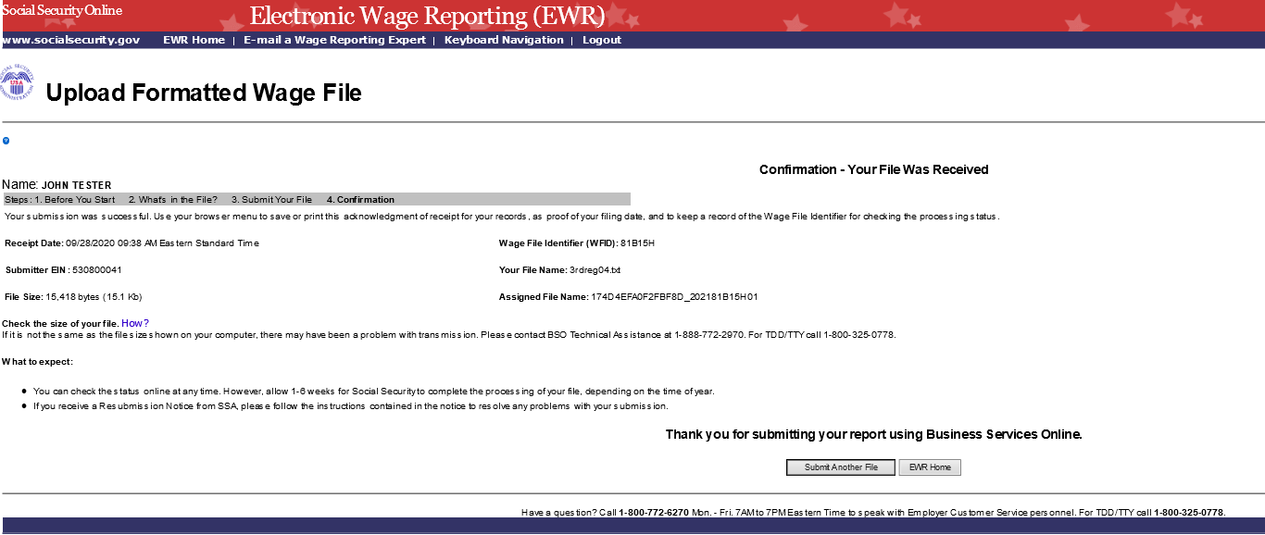
- Check the File Size displayed on the Confirmation page. If it is not the same as the file size shown on your computer, contact BSO Technical Assistance at 1-888-772-2970. To submit another file, select the Submit Another File button. To return to the EWR home page, select the EWR Home button or the EWR Home link at the top of the page.
Note: If a communications disruption occurs while you are submitting a wage file, log in again and select the View Submission Status link from the EWR home page to determine whether the file transfer was successful. If the submission is not displayed, you will have to submit it again. Select the same submission type that you initially selected.

Step-By-Step Instructions for Submitting a Special Wage Payments File
Follow the instructions below to submit a special wage payments file to the Social Security Administration (SSA). For information on preparing Special Wage Payment data files for electronic filing, go to Publication 957.
- Under the tab Upload Formatted Wage File on the EWR home page, select the Submit a Special Wage Payments File link, the system displays the “Submit Your Special Wage Payments File” page.
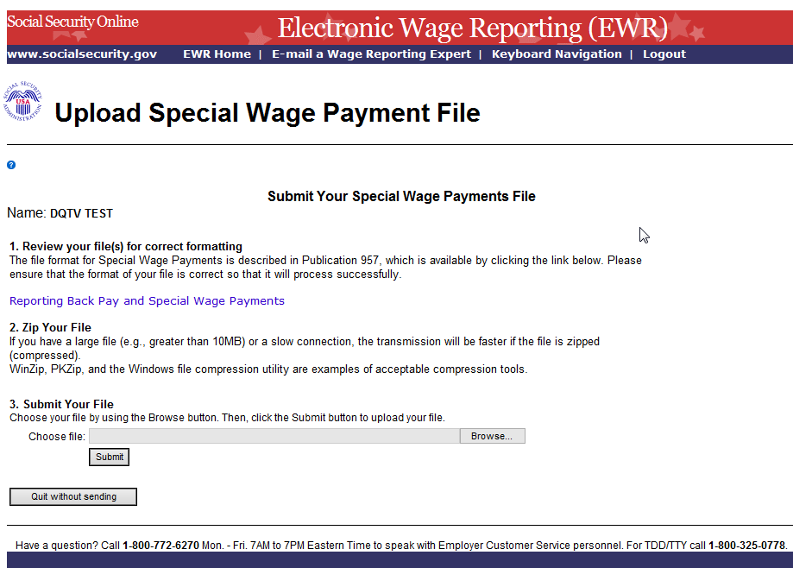
- On the Submit Your Special Wage Payments File:
  - Select the Reporting Back Pay and Special Wage Payments link to view the Internal Revenue Service (IRS) Publication 957, “Reporting Back Pay and Special Wage Payments to the Social Security Administration”.
  - To submit a your file, enter the name of a wage file in the Choose file field, or use the Browse button to select a wage file from your computer’s file system.
  - Select the Submit button to upload your file. During file transmission, an “in progress” window is displayed. When the file upload is completed, the system displays the “Confirmation – Your File Was Received” page. A pop-up window advising you to save and/or print the page will also appear.
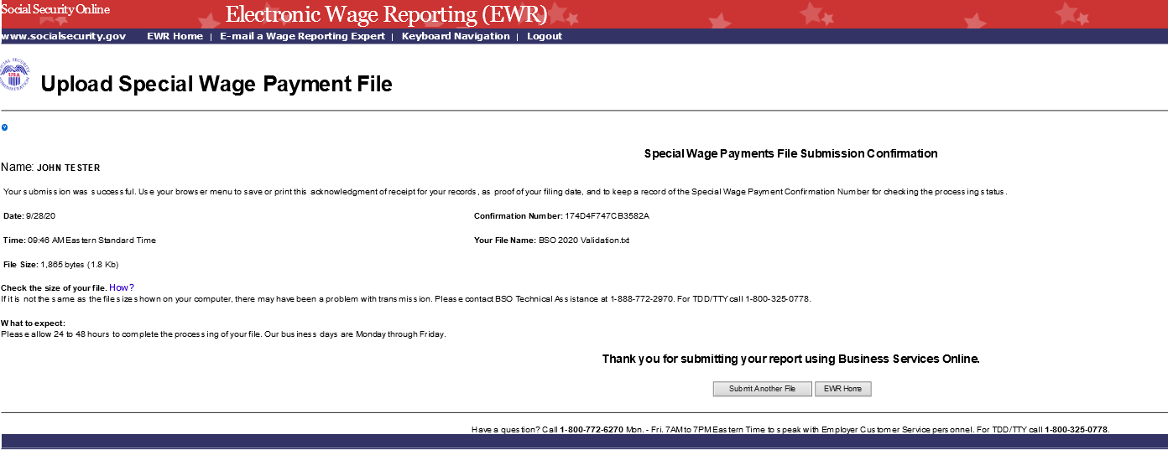
- To submit another file, select the Submit Another File button on the Confirmation page to return to the “Submit Your Special Wage Payments File” page. To return to the EWR home page, select the EWR Home button or the EWR Home link at the top of the page.

