Tax Year 2020 Submission Status Tutorial
Submission Status allows submitters to view the submission status, resubmission notice, errors, and detail submission information. You need to have the View File/Wage Report Status, Error, and Error Notices role in order to access the application. If you would like to view report level information submitted on your behalf by a third party, use the Employer Report Status application. See the Employer Report Status Tutorial for more information.

Step-By-Step Instructions
- Select Business & Government tab on the “Social Security” home page, then select Business Services menu to go to the “Business Services” page. On the “Business Services” page, select Log in or Use Business Services Online button to go to the “Business Services Online” page.
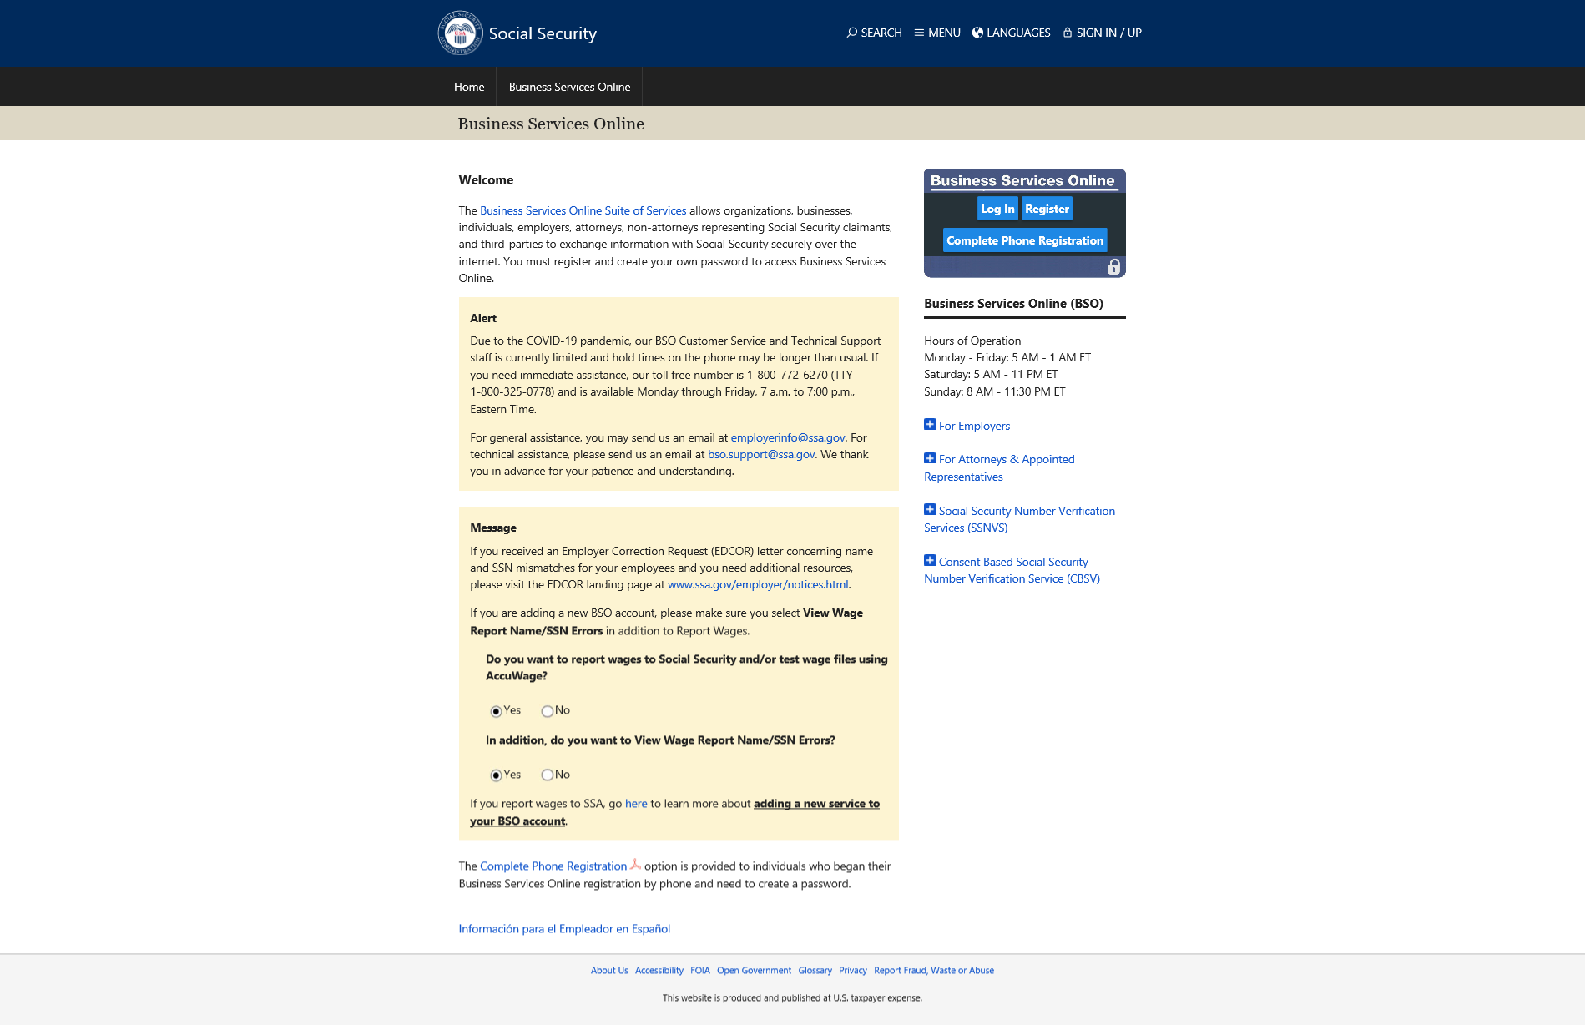
- Select the Log In button on the “Business Services Online” page. The system displays the “Log In to Online Services” page.
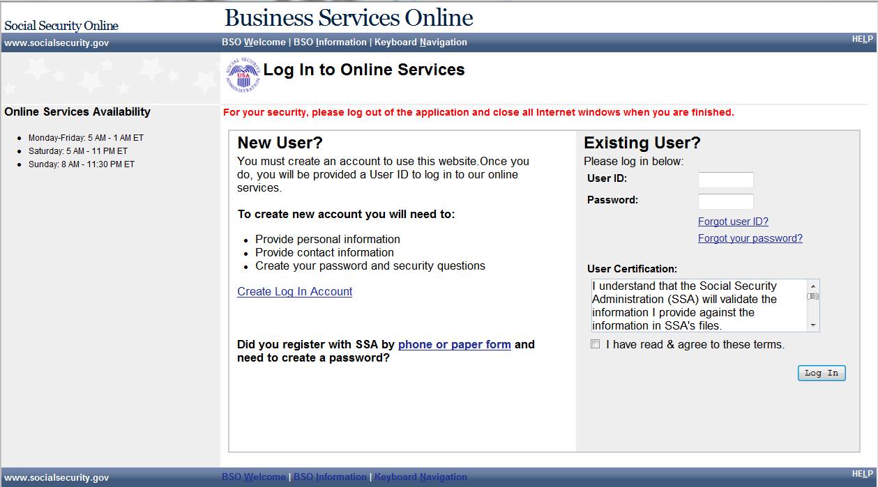
- Enter your User ID and Password.
- Select the I have read & agree to these terms check box on the “Log In to Online Services” page.
  - Select the Log In button to display the BSO “Main Menu” page.
  - To return to the “Business Services Online” page, select the BSO Welcome link at the top or bottom of the page.

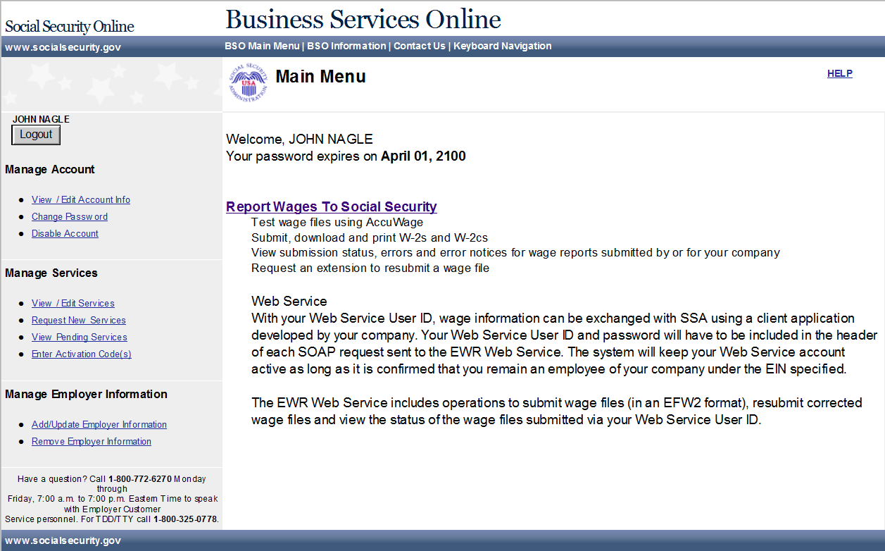
- Select the Report Wages To Social Security link on the BSO “Main Menu” page. The system displays the “Wage Reporting Attestation” page.
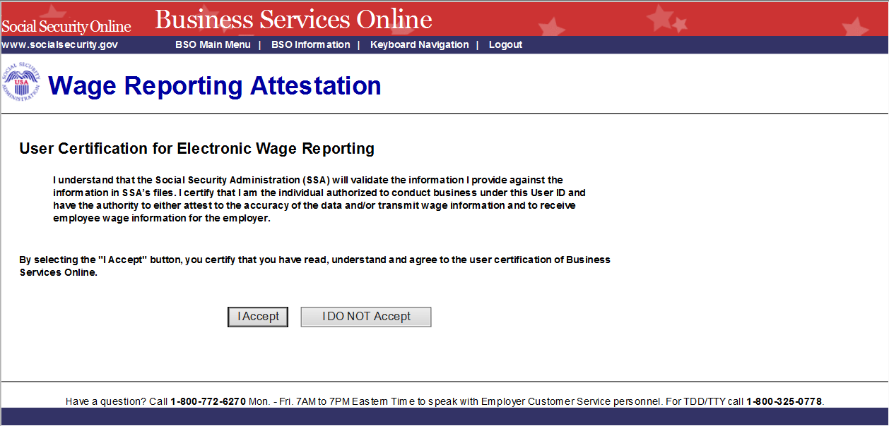
- Select the I Accept button on the “Wage Reporting Attestation” page to go to the “EWR home” page. To return to the BSO “Main Menu” page, select the I DO NOT Accept button.
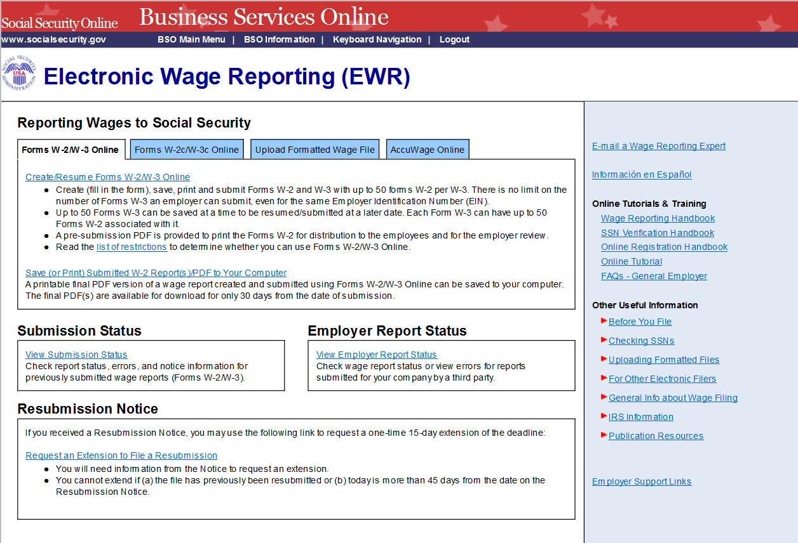
- Select the View Submission Status link to access Submission Status. The system displays the “Submission Search” page.
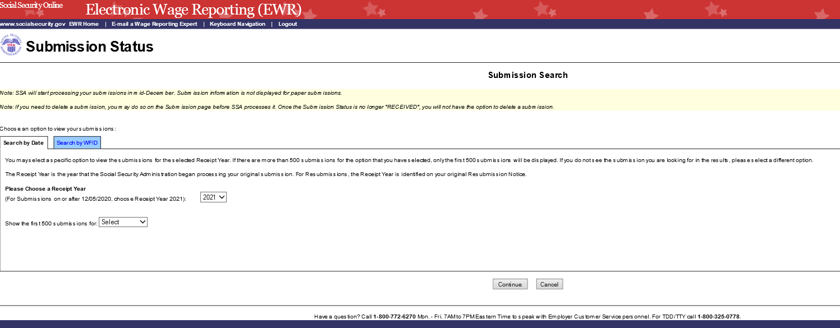
- You can search a submission by Date or by WFID on the “Submission Search” page.
  - Search by date: Search by Date is a default tab. Select a Receipt Year and a submission date range, then select Continue button to go to the “Search Results” page. If there are no submissions matching the date range selected, the system displays the Search Results page with a message.
  - Search by WFID: Select the Search by WFID tab to see the options listed on the “Submission Search” page. Select a Receipt Year and enter the WFIDs for the selected Receipt Year when you search by WFID on the “Submission Search” page. If there are no submissions matching the WFID entered, the system displays the Search Results page with a message. If you do not enter the WFIDs, the system displays all of the WFIDs for the selected Receipt Year on the “Search Results” page.
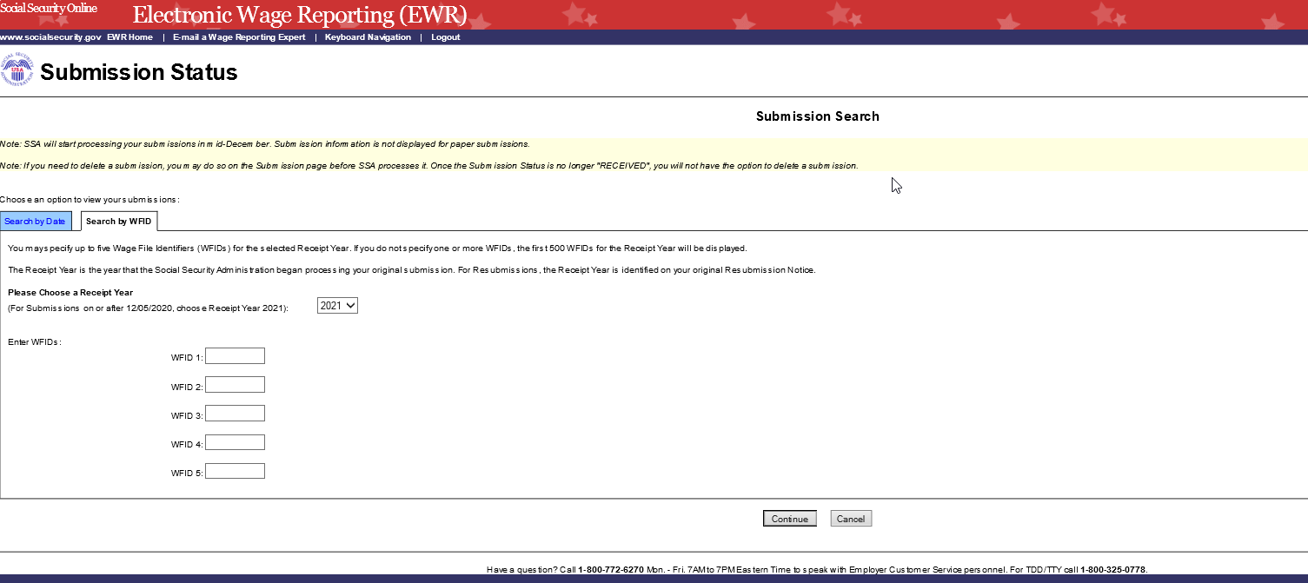

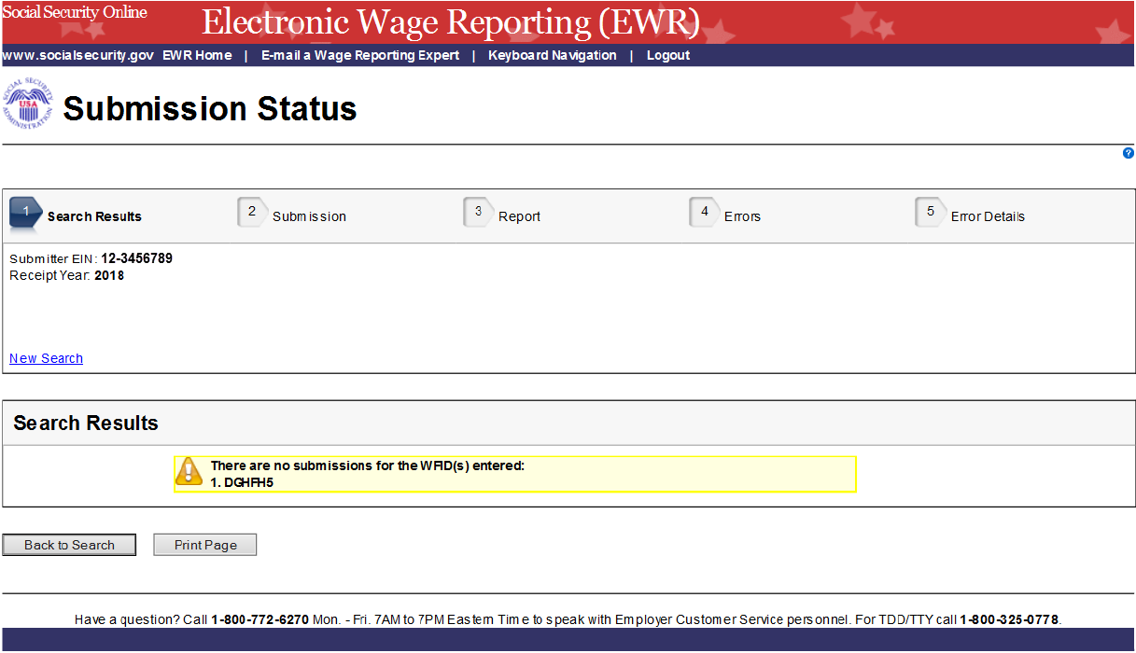
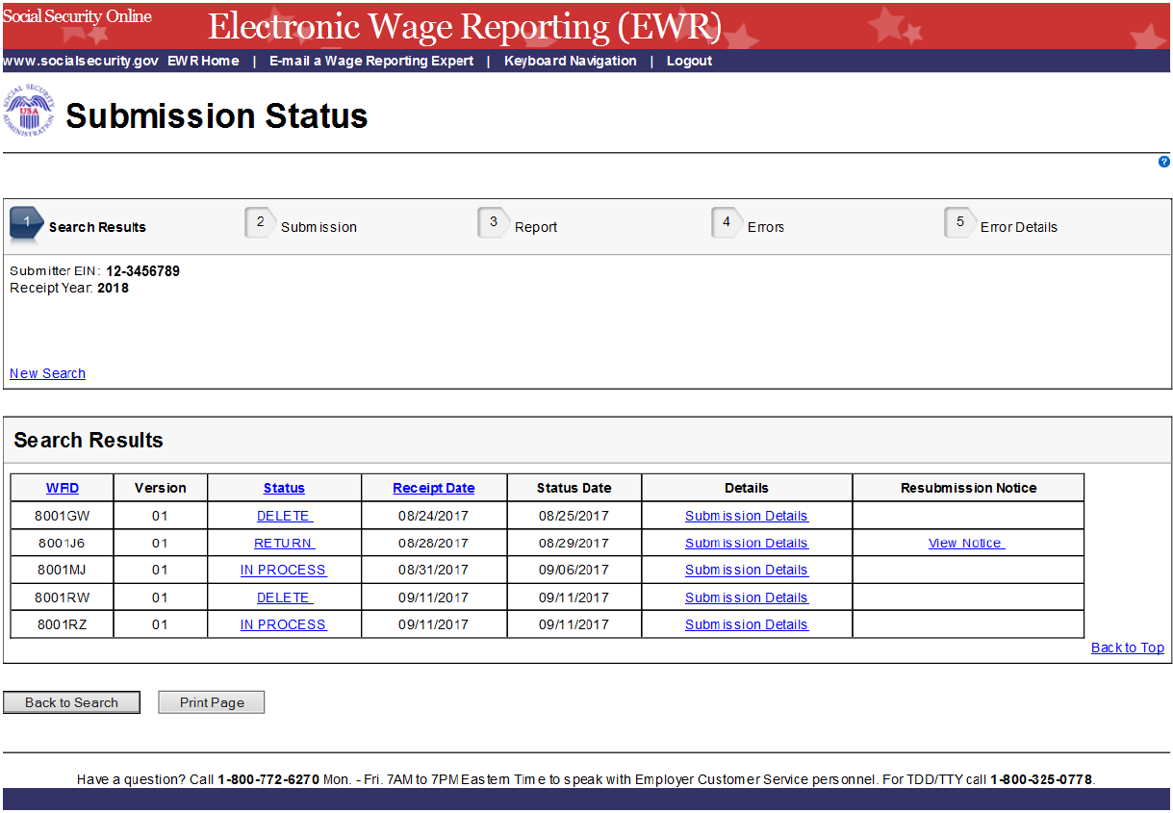
- On the Search Results page:
  - The Submission Status is displayed in the Status column. The possible submission statuses are: RECEIVED, IN PROCESS, COMPLETE, RETURN, DELETE, and DUPLICATE .
  - Select the column header WFID, Status or Receipt Date to sort submissions accordingly.
  - Select the specific Status to see an Explanation of Processing Status Code.
  - Select the Submission Details link in the Details column to see the “Submission” page. If the status is “RECEIVED”, the system displays the Submission page with a Delete This Submission button; if the status is “DELETE”, the system displays the Submission page with Overview and Current Status sections; if submission level error exists, the system displays the Submission page with submission error.
  - If Resubmission Notice exists, select the View Notice link in the Resubmission Notice column to see the Resubmission Notice.
  - Select the Back to Search button to return to the “Submission Search” page.
  - Select the Print Page button to print the “Search Results” page.
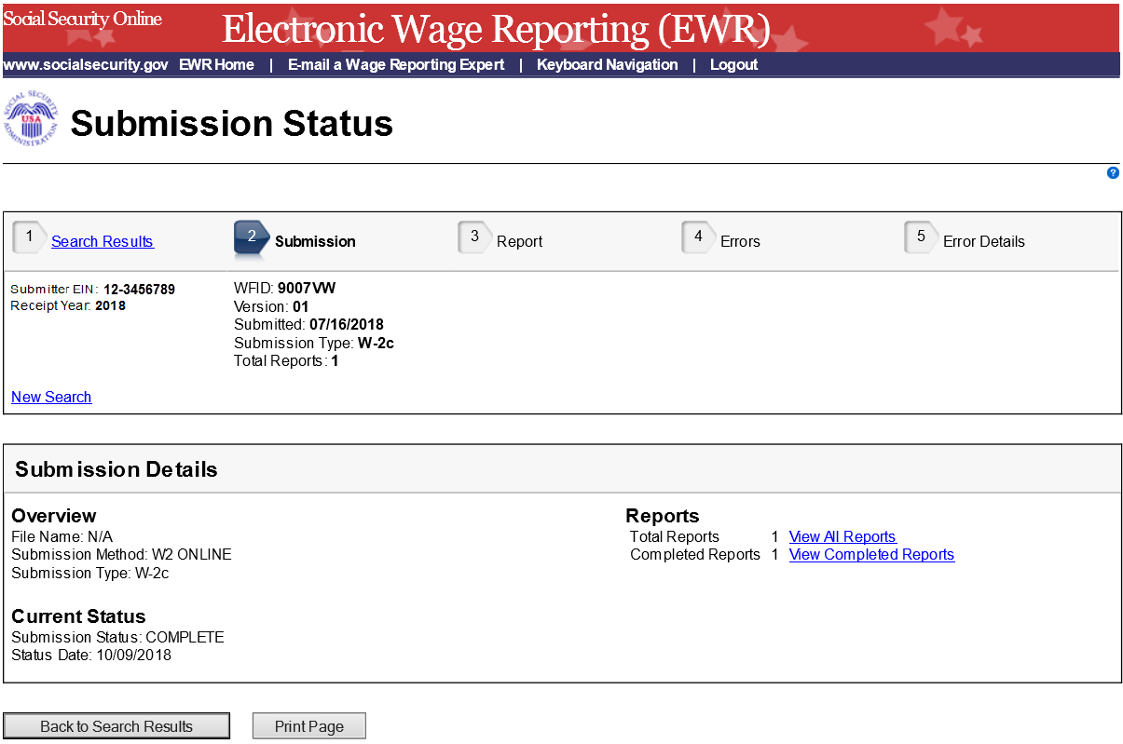
- On the Submission page:
  - Select any link in the Reports section to go to the Report page.
  - Select Search Results link or the Back to Search Results button to return to the “Search Results” page.
  - Select the Print Page button to print the “Submission Details” page.
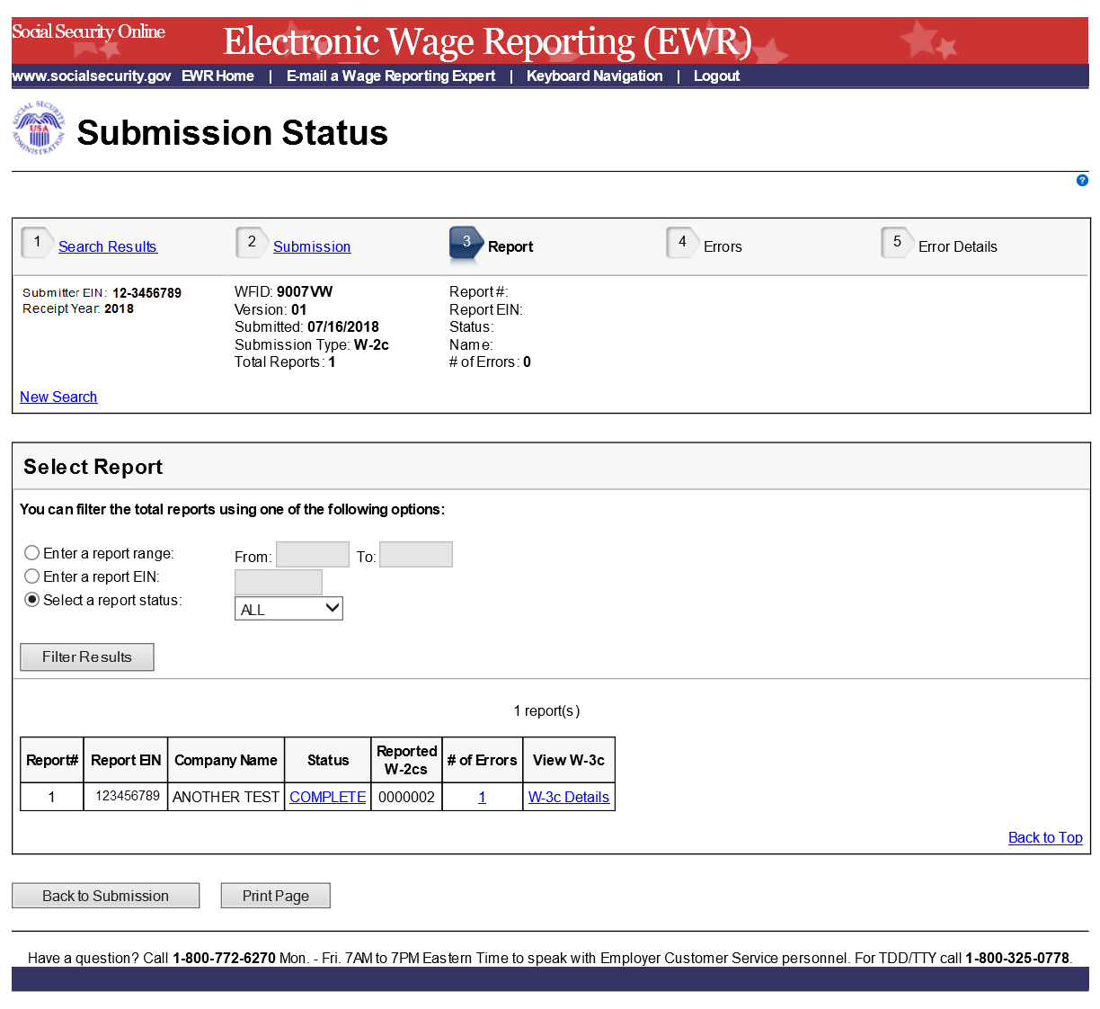
- On the Report page:
  - Select one of the filter radio buttons to filter the total reports accordingly. The report table will be refreshed.
  - Select the specific status link in the Status column to see an Explanation of Processing Status Code.
  - If the report has errors, select the # of Errors link to go to the “Errors” page.
  - Select the W-3 Details (or W-3c Details) link to view Detailed W-3 Information (or W-3c Information). See the screenshot below:
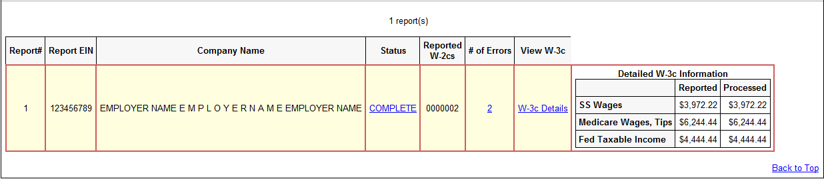
  - Select the Submission link or the Back to Submission button to return to the “Submission Details” page.
  - Select the Print Page button to print the “Report” page.
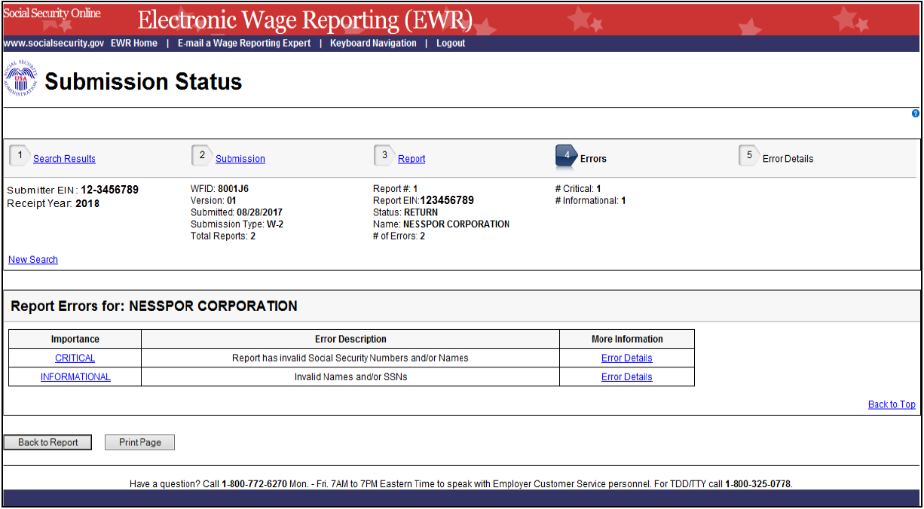
- On the Errors page:
  - Select the Importance link to see an Explanation of the Error Importance.
  - Select the Error Details link to go to the “Error Details” page.
  - Select the Report link or the Back to Report button to return to the “Report” page.
  - Select the Print Page button to print the “Errors” page.
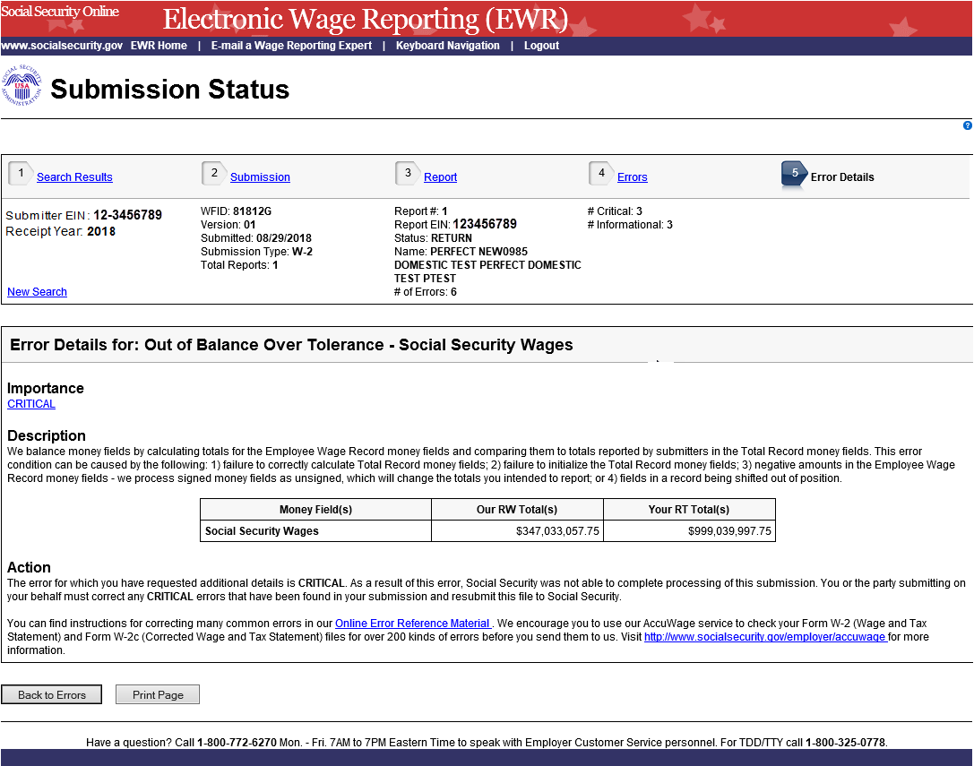
- On the Error Details page:
  - Select the Importance link to see an explanation of the Action that you may need to take.
  - Select the Online Error Reference Material link to see Employer W-2 Filing Instructions & Information.
  - Select the http://www.socialsecurity.gov/employer/accuwage link to see AccuWage Information and Software.
  - Select the Errors link or the Back to Errors button to return to the Errors page.
  - Select the Print Page button to print the “Error Details” page.

Appendix: Other pages
- Explanation of Processing Status Code (Submission Status) Page: users can access this page by selecting the specific status link in the Submission Status column or the Report Status column on any error page. Here is an example of “RECEIVED”.

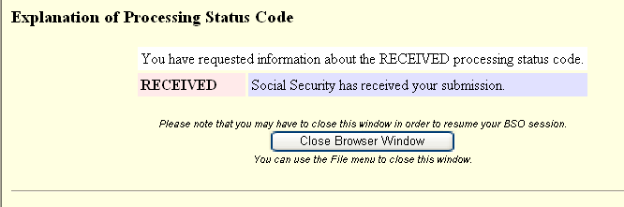

- Explanation of Error Importance Page: users can access this page by selecting either CRITICAL link or INFORMATIONAL link in the Importance column on any error page. Here is an example of “INFORMATIONAL” error.

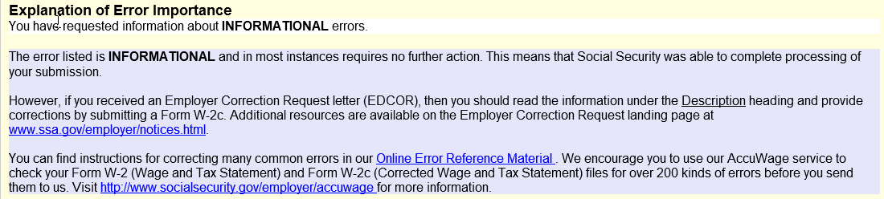

- Submission (with Error) Page: the “Submission (with error)” page displays any errors at the submission level.

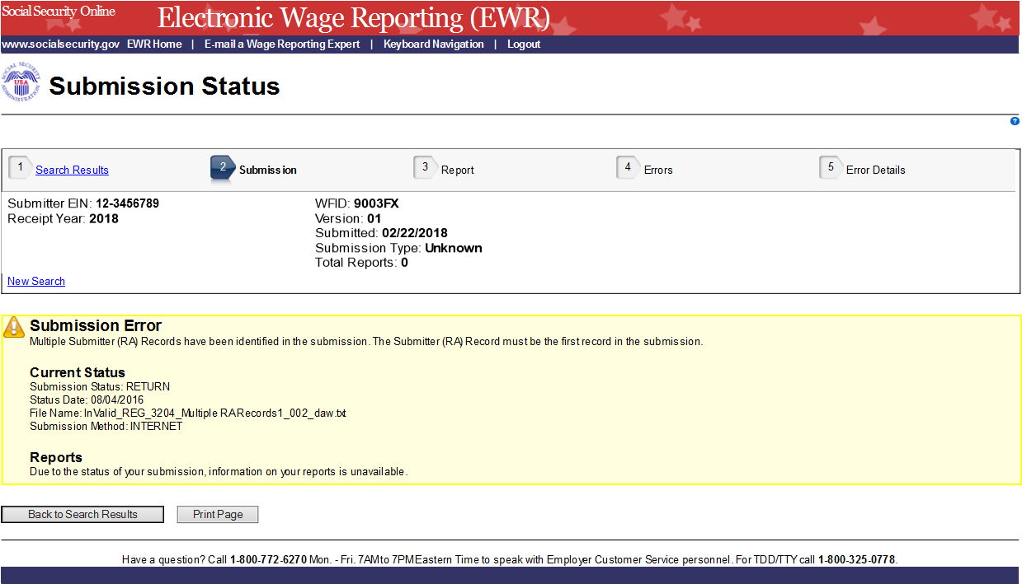

- Submission (when status is “RECEIVED”) Page

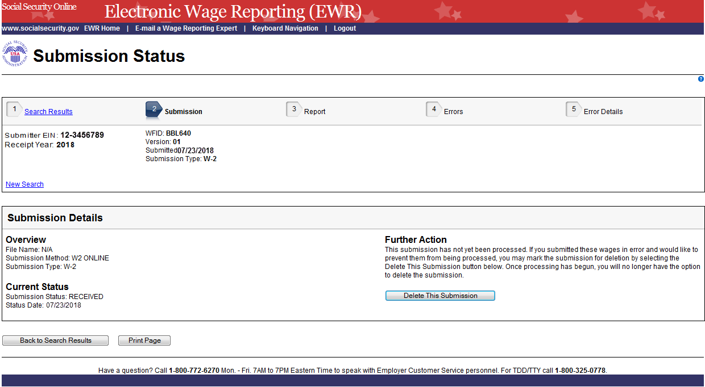

- Submission (when status is “DELETE”) Page

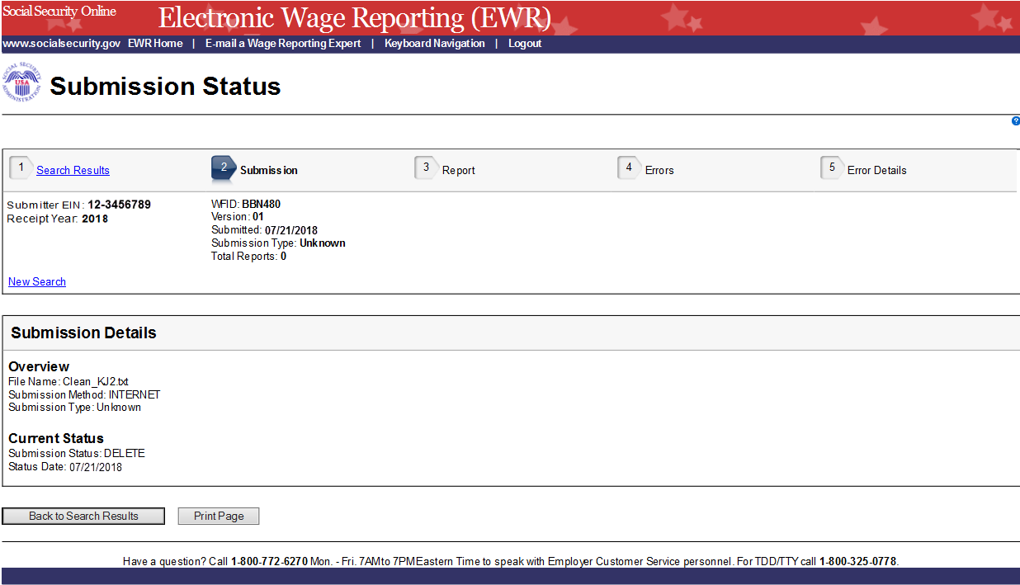
6. Resubmission Notice Page: on the “Search Results” page, select View Notice link to see the “Resubmission Notice” page. Select the Back to Search Results button to return to the “Search Results” page.
