Tax Year 2020 Employer Report Status Tutorial
Users can check wage report status or view errors for wage reports submitted for their companies by a third party. This option is available only to users who have the View File/Wage Report Status, Errors, and Error Notices role in their registration profile.

Step-By-Step Instructions

- Select Business & Government tab on the “Social Security” home page, then select Business Services menu to go to the “Business Services” page. On the “Business Services” page, select Log in or Use Business Services Online button to go to the “Business Services Online” page.
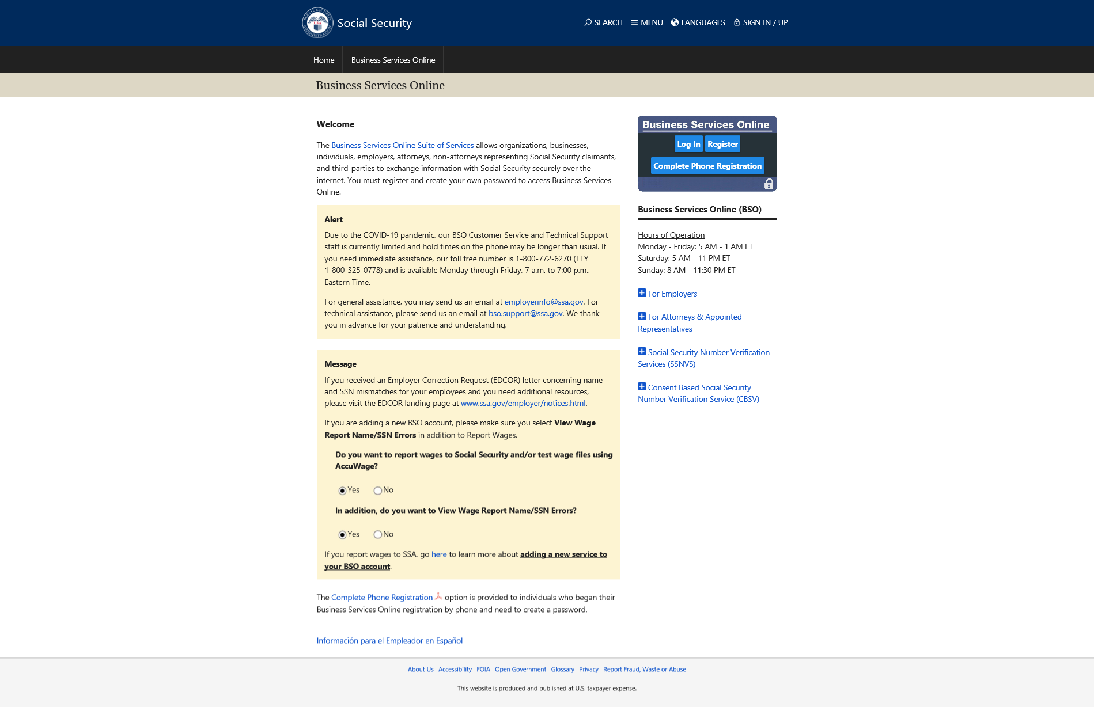
- Select the Log In button on the “Business Services Online” page. The system displays the “Log In to Online Services” page.
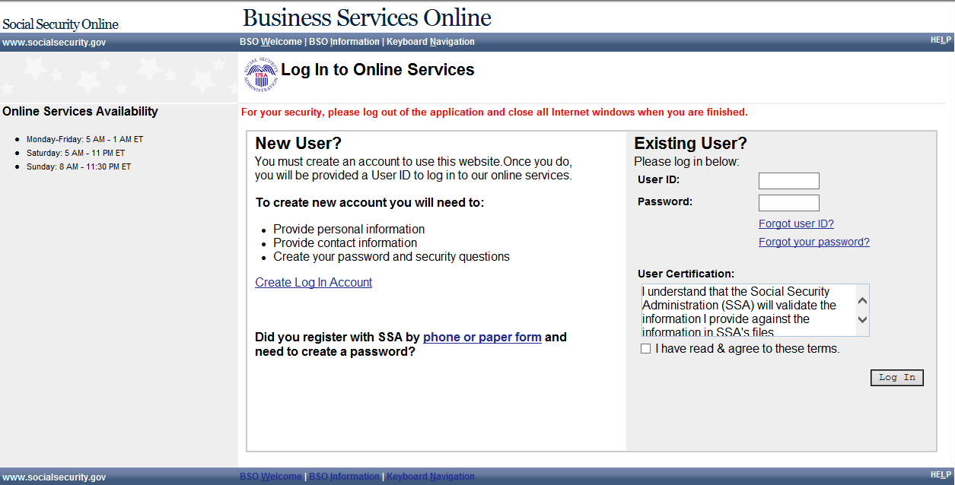
- Enter your User ID and Password.
- Select the I have read & agree to these terms check box on the “Log In to Online Services” page.
  - Select the Log In button to display the BSO “Main Menu” page.
  - To return to the “Business Services Online” page, select the BSO Welcome link at the top or bottom of the page.

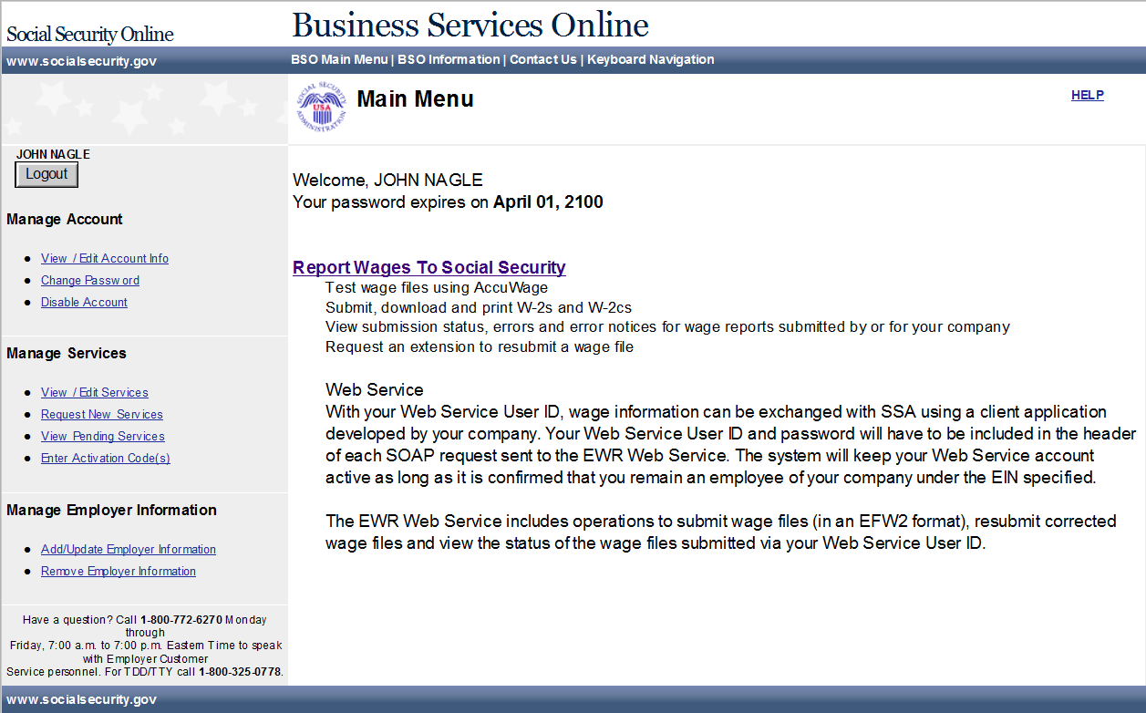
- Select the Report Wages To Social Security link on the BSO “Main Menu” page. The system displays the “Wage Reporting Attestation” page.
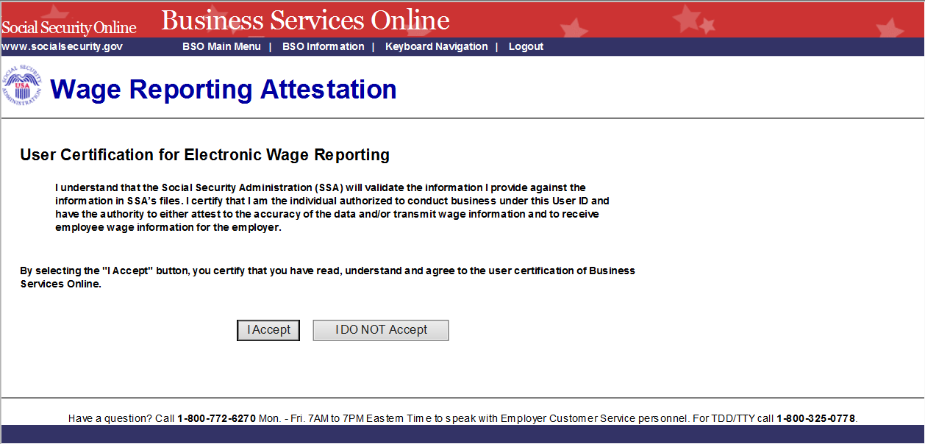
- Select the I Accept button on the “Wage Reporting Attestation” page to go to the EWR home page. To return to the BSO “Main Menu” page, select the I DO NOT Accept button.
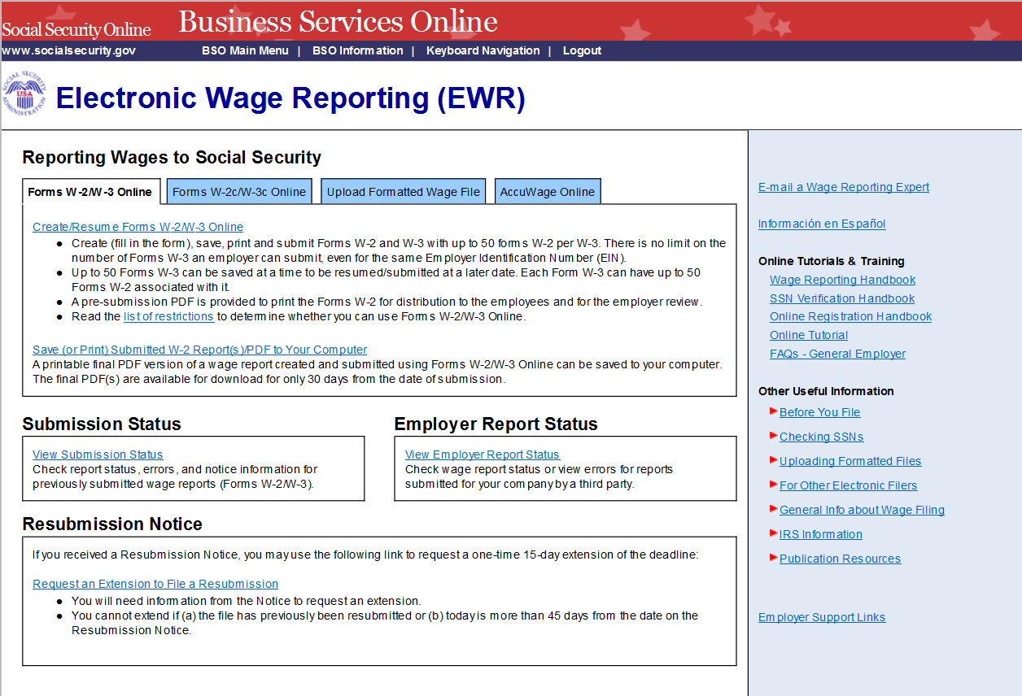

Select the View Employer Report Status link to go to the “Employer Report Selection” page.

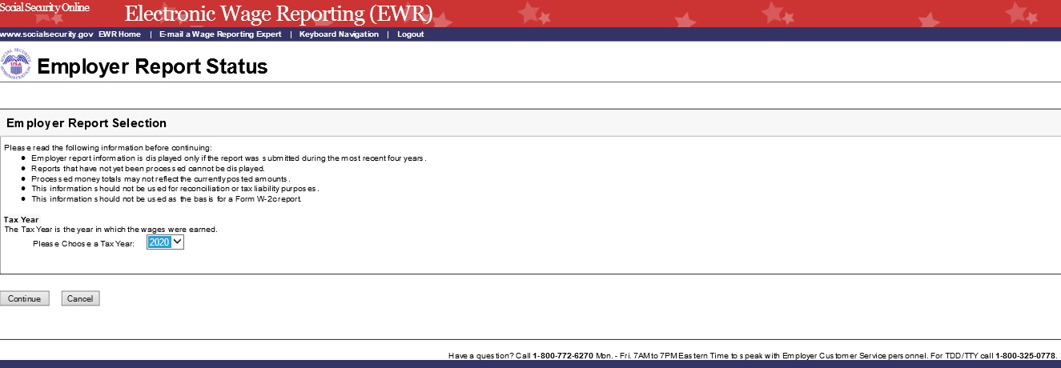
- Select a Tax Year. The current tax year is the default value.
  - Select the Continue button to go to the “Search Results” page.
  - If there is no Report Status available, the system displays the “Search Results” page with a message.
  - Select the Cancel button to return to the EWR home page.
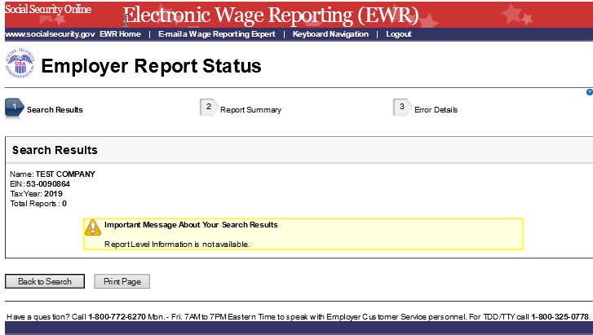
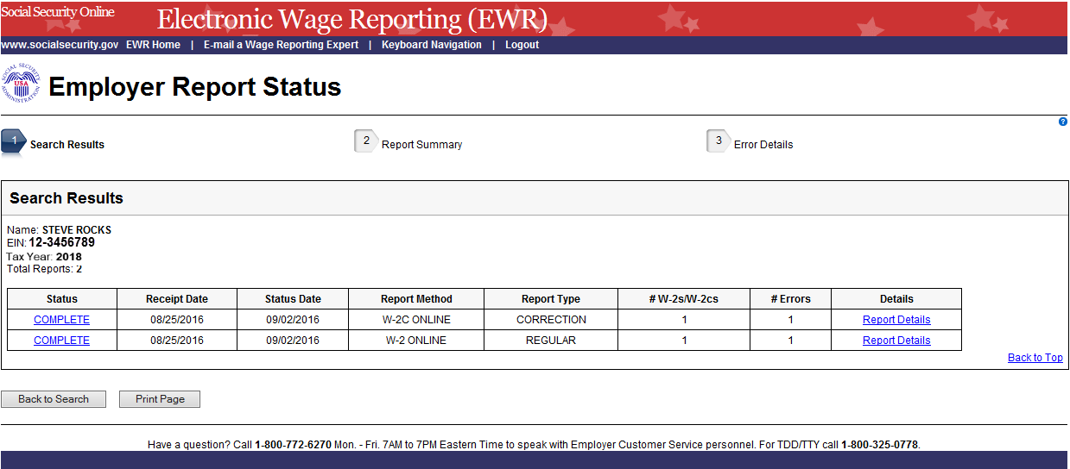
- On the Search Results page:
  - Select the Status link to see an Explanation of Processing Status Code.
  - Select the Report Details link to see the “Report Summary” page. If there is no error information available, the system displays the “Report Summary” page with a message.
  - Select the Back to Search button to return to the “Employer Report Selection” page.
  - Select the Print Page button to print the “Search Results” page.
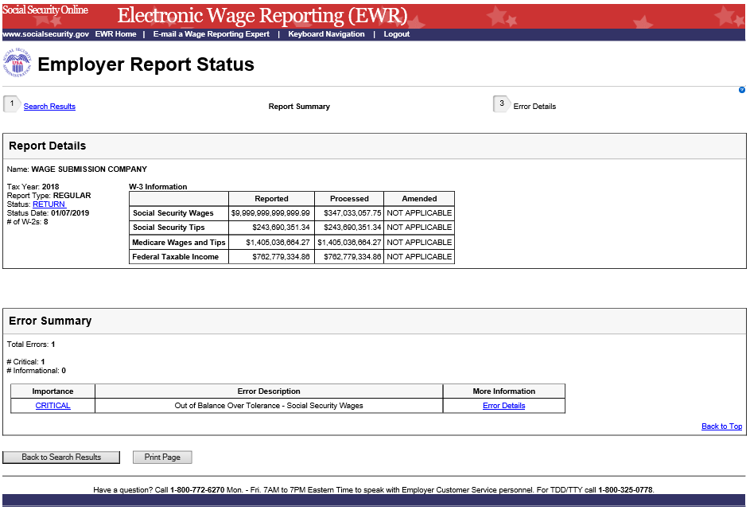
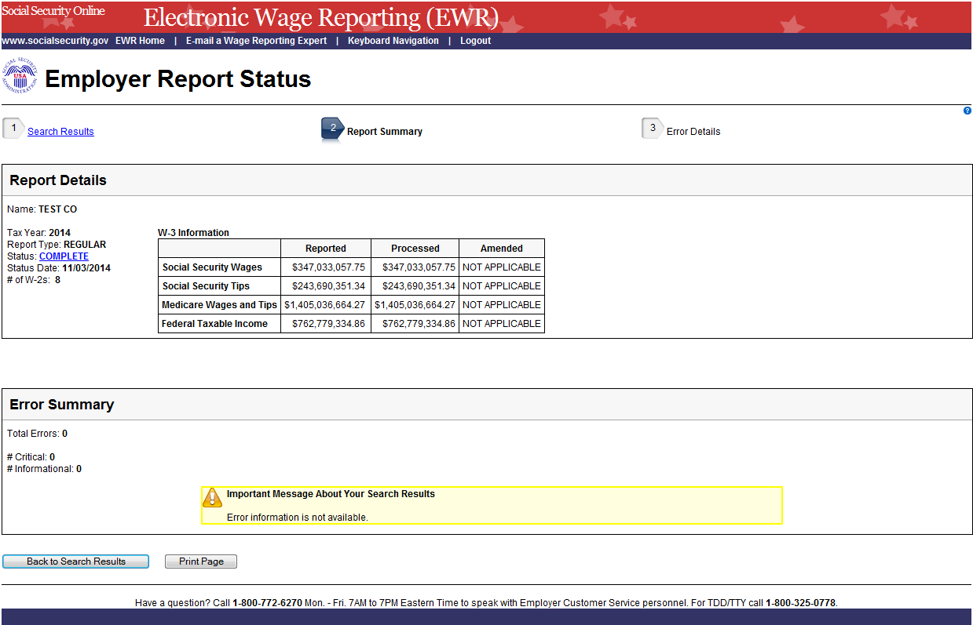
- On the Report Summary page:
  - Select the Status link in the Report Details section to see an Explanation of Processing Status Code.
  - Select the Importance link in the Error Summary section to see an Explanation of the Error Importance.
  - Select the Error Details link to go to the “Error Details” page.
  - Select the Back to Search Results button to return to the “Search Results” page.
  - Select the Print Page button to print the “Report Summary” page.
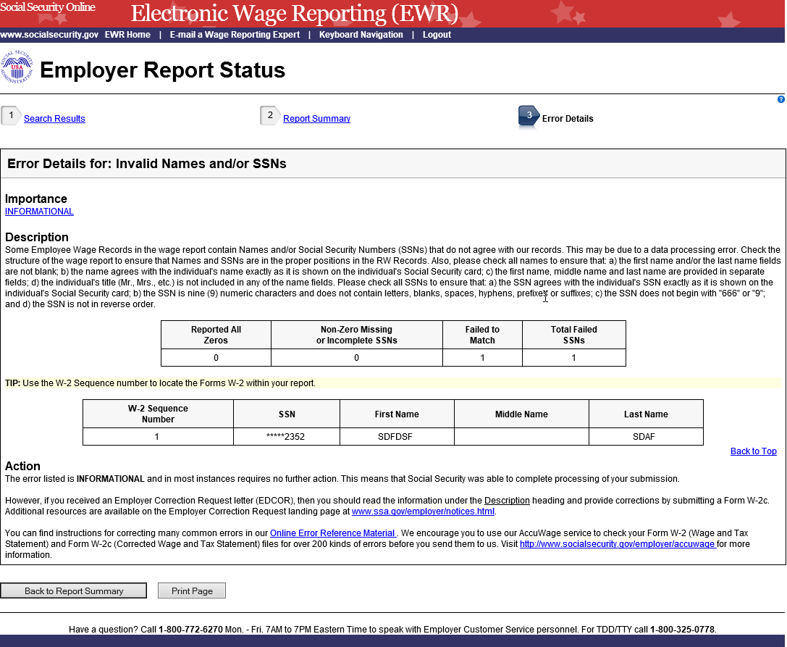
- On the Error Details page:
  - Select the Importance link to see an explanation of the Action you may need to take.
  - Select the Online Error Reference Material link to see Employer W-2 Filing Instructions & Information.
  - Select the http://www.socialsecurity.gov/employer/accuwage link to see AccuWage Information and Software.
  - Select the Back to Report Summary button to return to the “Report Summary” page.
  - Select the Print Page button to print the “Error Details” page.

Appendix: Other pages
- Explanation of Processing Status Code (Submission Status) Page: users can access this page by selecting the specific status link in the Submission Status column or the Report Status column on any error page. Here is an example of “RECEIVED”.
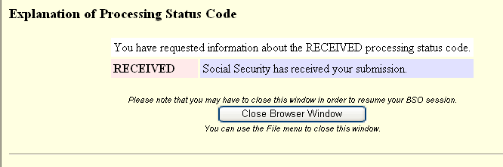
- Explanation of Error Importance Page: users can access this page by selecting either CRITICAL link or INFORMATIONAL link in the Importance column on any error page. Here is an example of “INFORMATIONAL” error.

