Tax Year 2023

Employer Report Status

Tutorial

Users can check wage report status or view errors for wage reports submitted for their companies by a third party.

1.0 Primary Pages
- Select the View Employer Report Status link on the EWR homepage. The system displays the “Employer Report Selection” page.
See “Accessing EWR Suite of Services Tutorial” for how to access the EWR homepage.
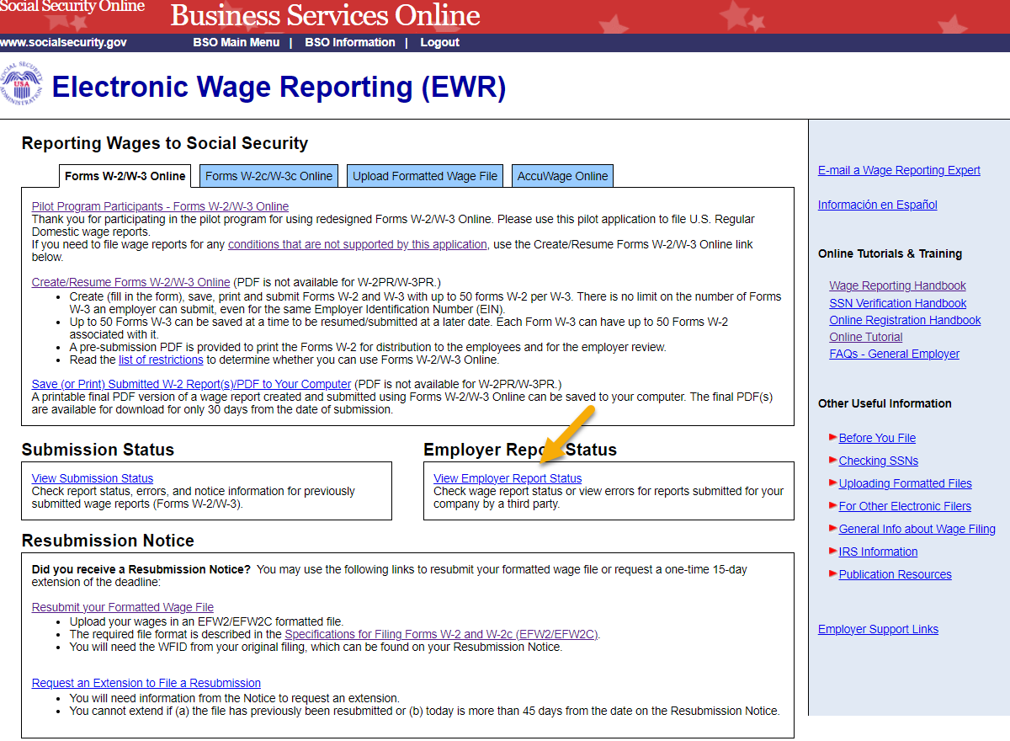
- On the “Employer Report Selection” page, select a Tax Year. The current tax year is the default value.
  - Select the Continue button to go to the “Search Results” page.
  - If there is no Report Status available, the system displays the “Search Results” page with a message.
  - Select the Cancel button to return to the EWR home page.
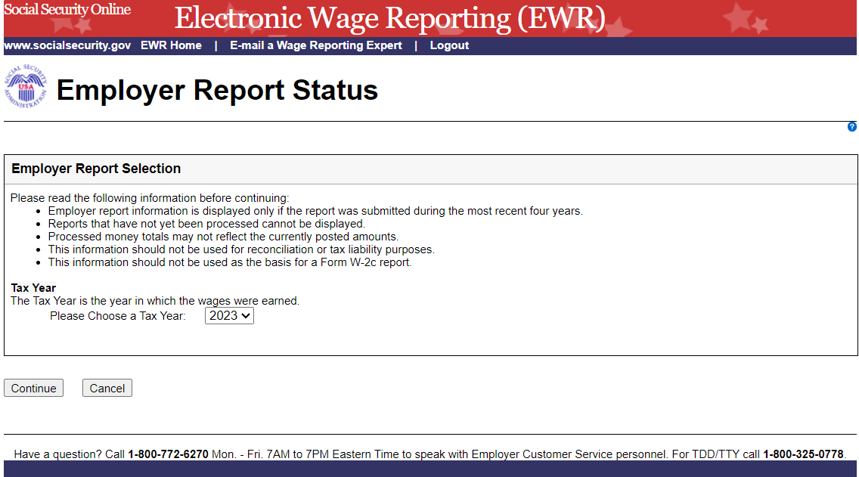
- On the Search Results page:
  - Select the Report Details link to see the “Report Summary” page. If there is no error information available, the system displays the “Report Summary” page with a message.
  - Select the actual status link to see an Explanation of Processing Status Code.
  - Select the Back to Search button to return to the “Employer Report Selection” page.
  - Select the Print Page button to print the “Search Results” page.
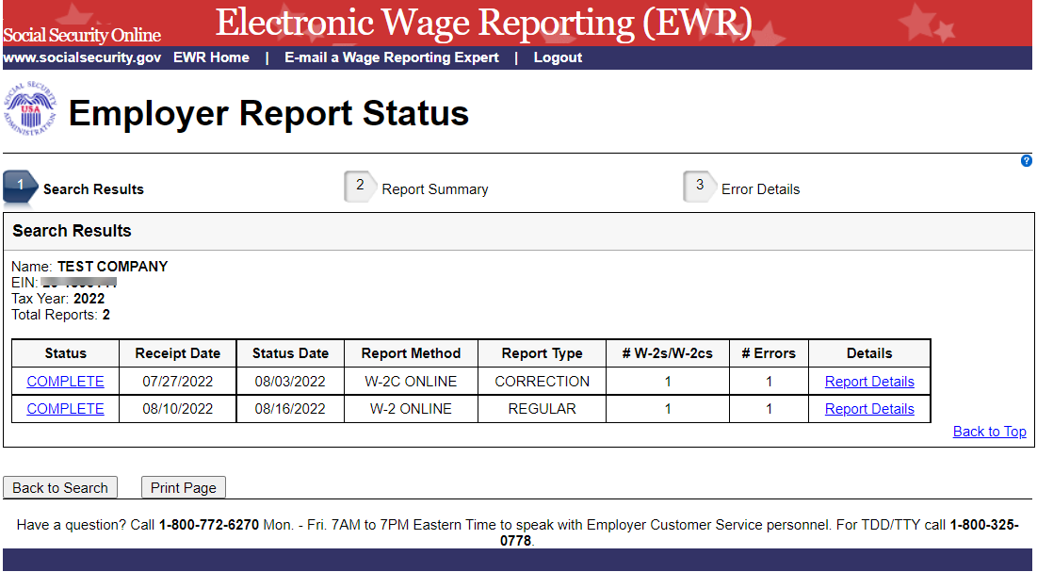
- On the Report Summary page:
  - Select the Error Details link to go to the “Error Details” page.
  - Select the actual status link in the Report Details section to see an Explanation of Processing Status Code.
  - Select the actual importance link in the Error Summary section to see an Explanation of the Error Importance.
  - Select the Back to Search Results button to return to the “Search Results” page.
  - Select the Print Page button to print the “Report Summary” page.
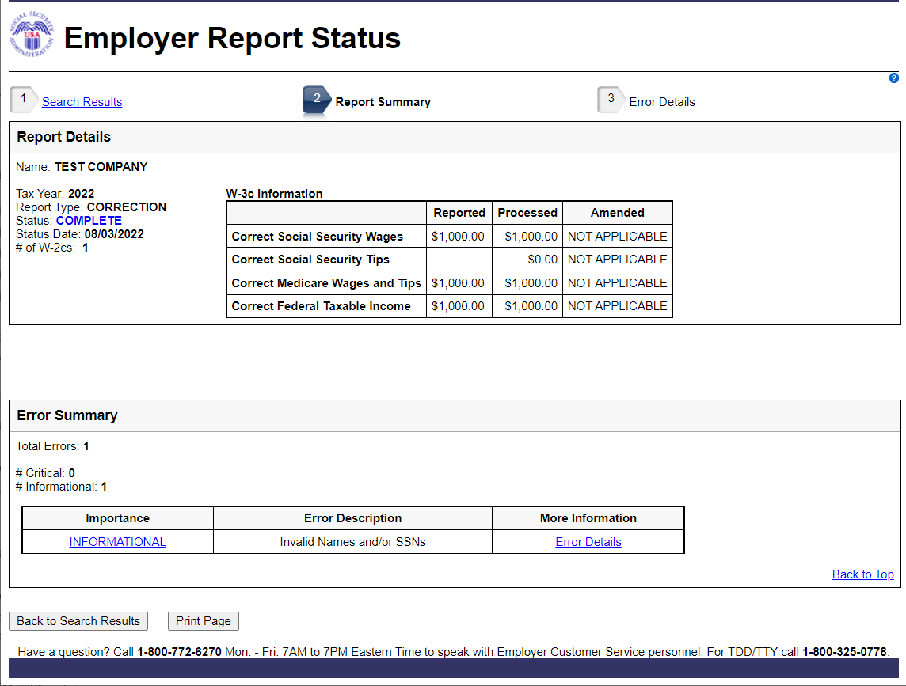
- On the Error Details page:
  - Select the Importance link to see an explanation of the Action you may need to take.
  - Select the https://www.ssa.gov/employer/notices.html link. The system displays the Employer Correction Request Notices (EDCOR) page.
  - Select the Online Error Reference Material link. The system displays the Online Error Reference Material page.
  - Select the http://www.socialsecurity.gov/employer/accuwage link. The system displays the AccuWage Online Information page.
  - Select the Back to Report Summary button to return to the “Report Summary” page.
  - Select the Print Page button to print the “Error Details” page.
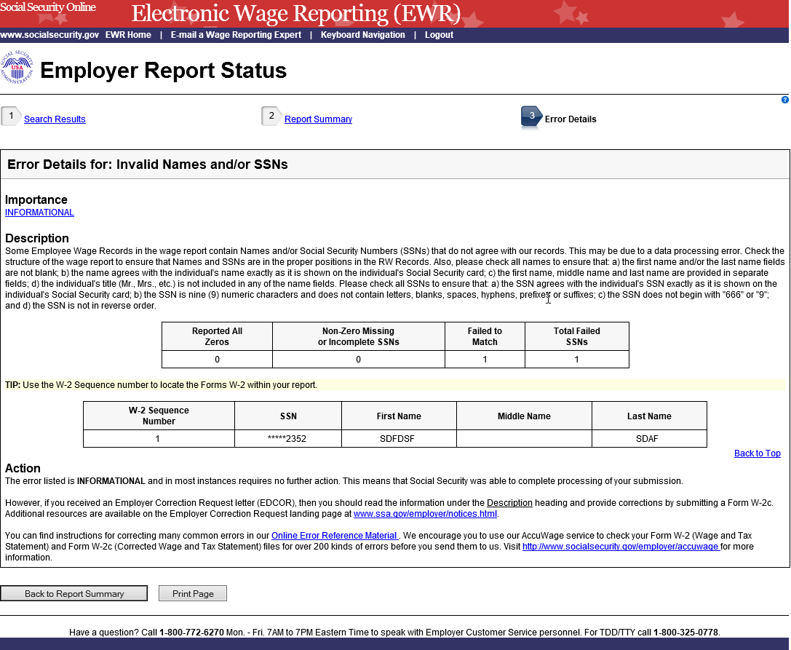

Other Pages

2.1 Explanation of Processing Status Code Page:

Users can access this page by selecting the specific status link in the Status column on any page. Here is an example of “COMPLETE” status page.

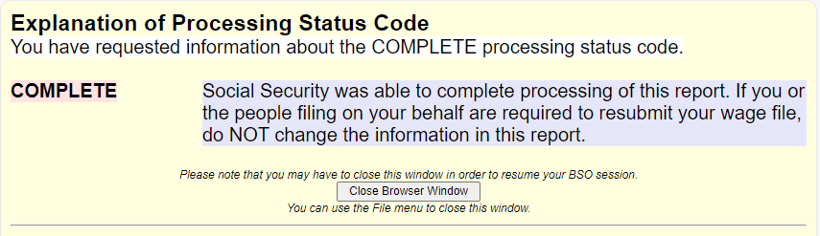

2.2 Explanation of Error Importance Page:

Users can access this page by selecting either CRITICAL link or INFORMATIONAL link in the Importance column on any error page. Here is an example of “INFORMATIONAL” error.

