Tax Year 2020 Request Resubmission Extension Tutorial

Step-By-Step Instructions
- Select “MENU” on the Social Security home page, then select Business Services to go to the “Business Services” page. On the “Business Services” page, select Log in or Use Business Services Online button to go to the “Business Services Online” page.
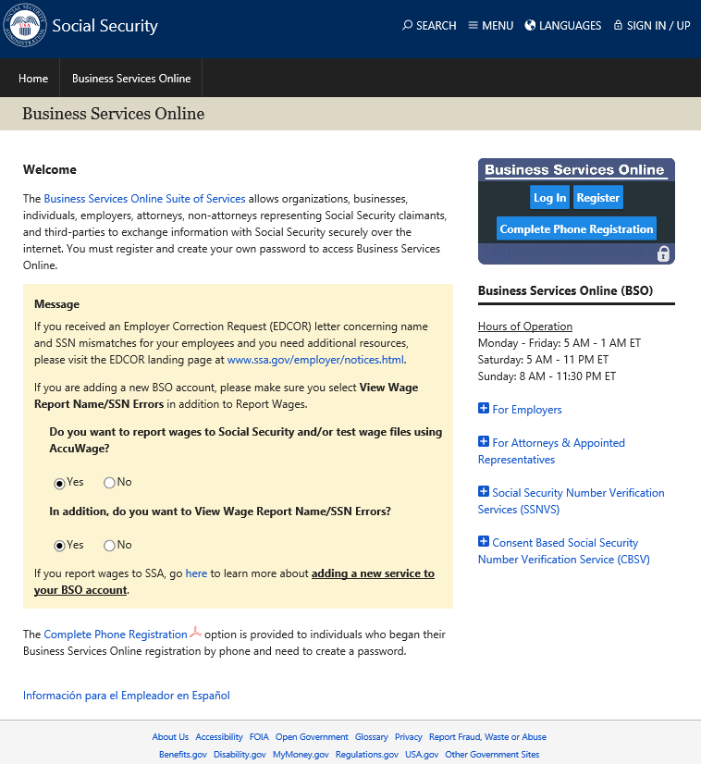
- Select the Log In button on the “Business Services Online” page. The system displays the “Log In to Online Services” page.
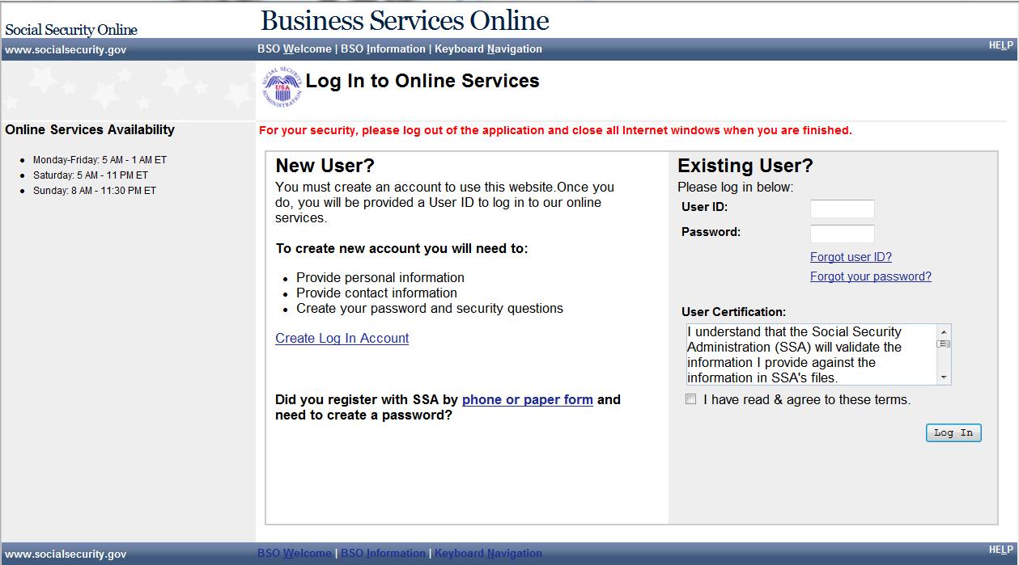
- Enter your User ID and Password.
- Select the I have read & agree to these terms check box on the “Log In to Online Services” page.
  - Select the Log In button to display the BSO “Main Menu” page.
  - To return to the “Business Services Online” page, select the BSO Welcome link at the top or bottom of the page.
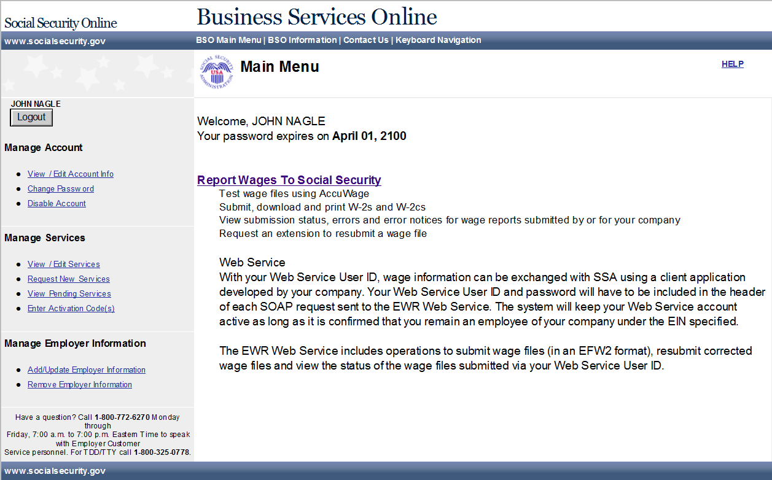
- Select the Report Wages To Social Security link on the BSO “Main Menu” page. The system displays the “Wage Reporting Attestation” page.
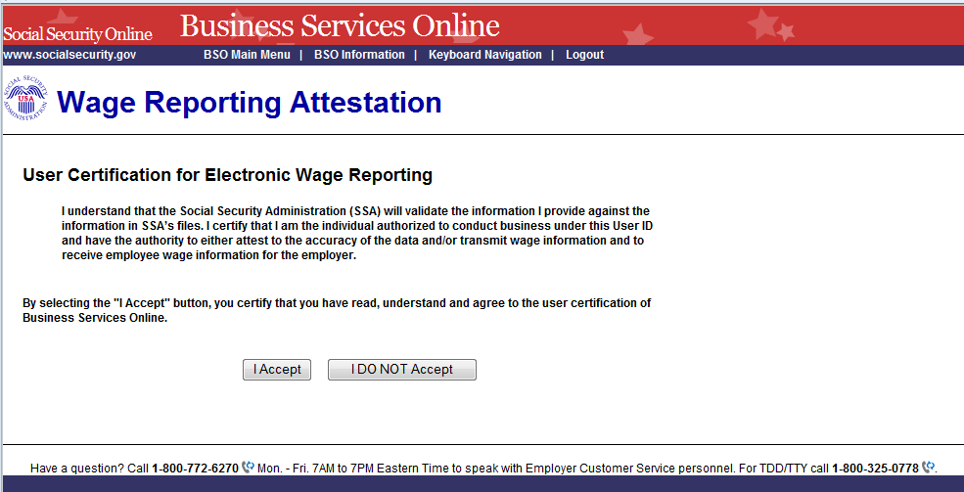
- Select the I Accept button on the “Wage Reporting Attestation” page to go to the EWR home page. To return to the BSO “Main Menu” page, select the I DO NOT Accept button.

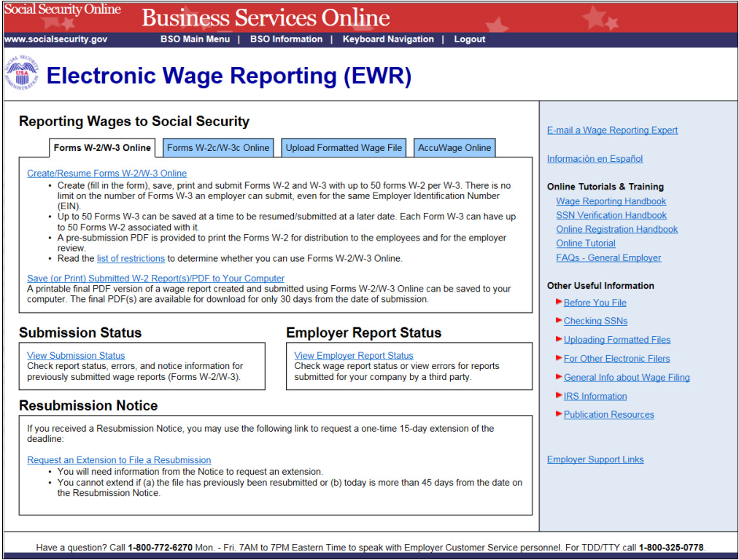
- Select the Request an Extension to File a Resubmission link on the EWR home page. The system displays the “Request Resubmission Extension” page.
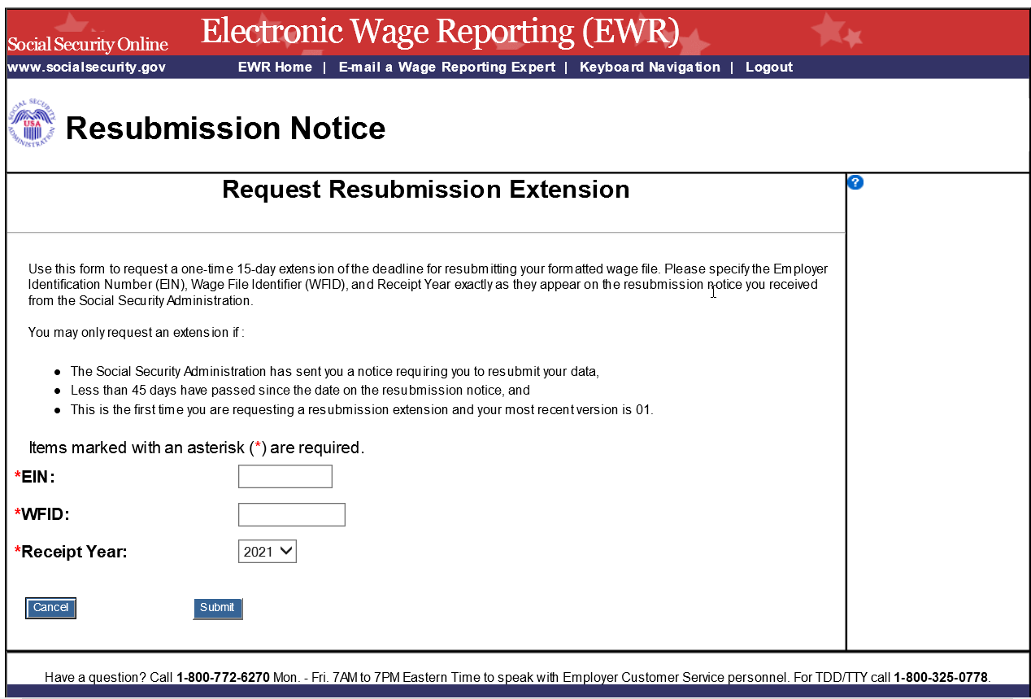
- Enter your Employer Identification Number (EIN), Wage File Identifier (WFID), and Receipt Year (exactly as they appear on the resubmission notice you received from SSA.)
  - Select the Submit button to request an extension on the deadline for resubmitting your formatted wage file, the system displays the “Resubmission Extension Receipt” page.
  - To return to the EWR home page, select the Cancel button.

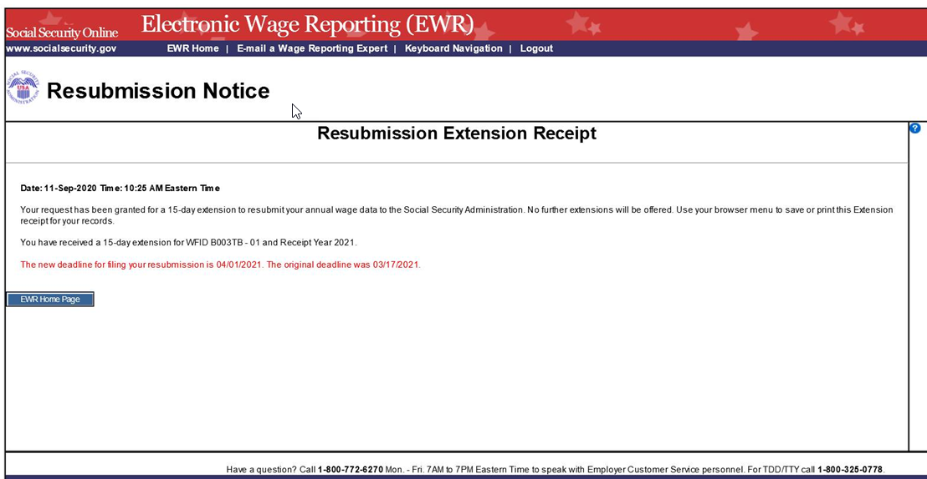
- On the “Resubmission Extension Receipt” page, select the EWR Home Page button to return to the EWR home page.

